**ANNEX VI**

**FIRST ANNUAL NARRATIVE REPORT**

* This report must be completed and signed by the contact person of the coordinator.
* The information provided below must correspond to the financial information that appears in the financial report.
* Please complete the report using a typewriter or computer ***(you can find this from at the following address <specify>).***
* Please expand the paragraphs as necessary.
* ***Please refer to the special conditions of your grant contract and send one copy of the report to each address mentioned***.
* The contracting authority will reject any incomplete or badly completed reports.
* Unless otherwise specified, the answer to all questions must cover the reporting period as specified in point 1.6.
* Please do not forget to attach to this report the proof of the transfer of ownership referred to in Article 7.5 of the general conditions.

**Table of contents**

**List of acronyms used in the report**

1. **Description**

1.1. Name of coordinator of the grant contract:

1.2. Name and title of the contact person:

1.3. Name of beneficiary (ies) and affiliated entity (ies) in the action:

1.4. Title of the action:

1.5. Contract number:

1.6. 01/01/2019 and 31/12/2019 of the actions:

1.7. Target country (ies) or region (s):

1.8. Final beneficiaries &/or target groups (if different) (including numbers of women and men):

1.9. Country (ies) in which the activities take place (if different from 1.7.):

**2. Assessment of the implementation of action activities and its results:**

**2.1. Executive summary of the actions:**

In twelve months of EIDHR project, the implementing partner CTA undertook various activities as per the project proposal and was able to achieve the mentioned output successfully.

Firstly, through Tibetan Voluntary Health Association, CTA was able to provide direct financial aid to 16 human rights defenders in India out of which there 13 males and 3 females in the form of a monthly stipend. 12 beneficiaries have received medical support under this project.

Secondly, Tibetan Task Force on negotiation held a total of five meeting in these twelve months project period: two strategic development meetings in Dharamsala and three exclusive meetings- first exclusive meeting in London, second in Washington DC, and the final exclusive meeting in Dharamsala. The aim and objective of such meeting was to provide platform to share information with multiple stakeholders on the latest development in the People Republic of China (PRC). Also, provide platform to various democracy activist, Chinese human rights activist, and four Chinese experts in the field of negotiation who can share their opinion, experience, and on various negotiation strategy, which can help to plan strategies to road map to resolve the Tibet's issues with PRC government.

Finally, to improve the human rights situation inside Tibet and garner international support for the protection of Tibet's environment, various activities were taken which include the publications of papers, articles and presentation on topics like surveillance, censorship, and sustainable development related to Tibet aimed at raising awareness on human rights abuse faced by Tibetan inside Tibet. Also, to encourage concrete actions and intervention to resolve such crisis with the support from international communities.

**Impact:**

Improved human rights situation for the Tibetans in Tibet (PRC) and enhanced international support towards environmental protection of the Tibetan plateau.

**2.2. Result and activities**:

**A. RESULTS**

The result of programmatic action will be visible around the project completion period.

1. Outcome: - "<Title of the outcome>
2. **Direct Financial Aid for 42 HRDs in India:**

***Outcome no 1:***

1. Tibetan HRDs in India are enabled to continue on their human rights work safely and effectively.
2. One beneficiary who was a torture victim of PRC government had escaped to India has reached India 05/10/2018 with a very critical and poor health conditions because of brutal tortures of PRC government to him and also caused him a major brain problem. His physical and mental status was weaker and than other torture survivors and had to undergo medical treatment where the medical expenses are unbearable and high. Also, he has no relative who could look upon his huge medical expenses. However, with the help of EC grant he was able to undergo medical treatment and was recovered very well.
3. Through this project in order to uplift and empower women, Tibetan Voluntary Health Association was able to review the TTSP guidelines and input material allowance to the women during their pregnancy time as women are vulnerable. Application has been submitted to higher authority and decision is yet to be finalized.

***Output no 1:***

***1.3. Financial Aid for 42 HRDs in India:***

1.3.1. Tibetan human rights defenders who are survivors of human rights abuse by the PRC government are provided with adequate housing, medical care and a monthly stipend.

1.3.2. In these twelve months project period, 16 beneficiaries have received a monthly stipend. Out of 16 beneficiaries, 3 are female and 13 male. 12 beneficiaries have received medical support under this project.

1.3.3. Among 16 beneficiaries, 8 are above 65 years, 2 beneficiaries are nun and 6 are monks

1.3.4. To maintain official record and transparency, all the monthly stipends and medical expenses have been remitted directly into beneficiaries' bank account. Except one beneficiary who is a brutal torture survivor of PRC government have caused him a mental illness. Therefore, his stipends have been reimbursed in cash on his request.

1.3.5. As per the guidance of EU M&E and HRDs coordinator in India, we did a focus group discussion for current program beneficiaries. Individual interview was conducted to three beneficiaries in the third quarter of this project period. Interview for rest of the beneficiaries will conduct in next quarter.

***\*Monthly wise stipend beneficiary list:***

|  |  |  |  |  |
| --- | --- | --- | --- | --- |
| **Month** | **Beneficiary** | **Male** | **Female** | **Remarks** |
| January | 11 | 9 | 2 |  |
| February | 11 | 9 | 2 |  |
| March | 12 | 10 | 2 | One new beneficiary in March |
| April | 12 | 10 | 2 |  |
| May | 13 | 10 | 3 | One new beneficiary in May |
| June | 13 | 10 | 3 |  |
| July | 14 | 11 | 3 | One new beneficiary in July |
| August | 13 | 10 | 3 | One migrated to Australia |
| September | 13 | 10 | 3 | One new beneficiary and one migrated to Australia in September |
| October | 12 | 9 | 3 | One beneficiary admitted to Jampaling OPH, Dharamsala |
| November | 13 | 10 | 3 | One new beneficiary in November |
| December | 13 | 10 | 3 |  |

**2. Support to Tibetan Task Force for dialogue and negotiation:**

***Outcome no 2:***

Enhanced responsive and effectiveness of the Tibetan Task Force on negotiation with the PRC government.

***Output no 2:***

1. Tibetan Task Force for dialogue and negotiation is informed with experts' perspective on current sentiments of the Chinese people vis-a-vis the Tibetan issues.
2. Tibetan Task Force for dialogue and negotiation has updated and advanced strategies for outreach with the PRC government.
3. Tibetan Task Force members are enabled to meet regularly to exchange ideas and update their strategy plans.

***2.1. Tibetan Task Force on negotiation is informed with experts' perspective on current sentiment of the Chinese people and the PRC government vis-a-vis the Tibetan issues.***

2.1.1. Identified and recruited four Chinese liaison officers in Washington DC, Taiwan, Canberra, and Geneva. The consultant are appointed on staggered terms in order to assist the Task force members throughout the project cycle, particularly to brief to issues and the development related with the PRC.

2.1.2. Four Chinese liaison officers have assisted and provided insight into the thinking of PRC government officials as well as general sentiment of the Chinese people vs-a-vis the Tibet issue to develop realistic persuasion strategy.

***Major activities by the Chinese consultant based in Taipei, Taiwan:***

2.1.3. The consultant assisted to publish 1000 copies of Tibet's independence proved through Chinese government records', a research work which took Mr. Liu Hancheng more than 10 years to complete. Published as a 36th series of Gangjong, the book is an important historical work, which sheds light on Tibet being a separate country as mentioned in the annals of Manchu and Ming history.

2.1.4. The consultant published 6000 copies of calendar for free distribution to mark the year 2020 as 'Thank You Dalai Lama' by the Central Tibetan Administration. The calendar contains excerpts from His Holiness speeches, important contributions and great achievements of His Holiness the 14th Dalai Lama.

2.1.5. In collaboration with the Office of Tibet, Taiwan the consultant published 4000 copies of 37th issue of 'Kunsel Woenang', a quarterly journal in mandarin featuring selected articles on Tibetan religion, culture and Tibet issue for free distribution.

2.1.6. The consultant has assisted the Office of Tibet, Taiwan to make E-books on His Holiness Dalai Lama's speech during his 3rd visit to Taiwan, 2009 and His holiness the Dalai Lama teaching on 'In Praise of Dharmadhatu' in simplified Chinese language used in Tibet and China. These have been done in keeping in mind the reach and accessibility of social media. These E-books have been shared and sent online to Chinese liaison officers and those with knowledge of Chinese language.

* ***Awareness of Tibet issue through media outlet:***

2.1.7. The consultant and editor of Kunsel Woenang discussed the contents of Gangjong book series and introduced Tibetan history to Wolf, an online video portal. The episodes numbering around 30 have been made available online for public viewing.

2.1.8. The consultant had organised a radio interview for author Liu Hancheng with a radio channel on 21st October 2019. Mr. Liu Hancheng spoke about his book on Tibetan history, Tibet's independence proved through Chinese government records.

2.1.9. On 23rd October, the consultant along with the staff from the Office of Tibet, Taiwan participated in a radio interview program organised by Radio Free Asia (RFA) and spoke about the conference, Finding Common Ground: International Conference of Tibetologist. In an interview to RFA consultant and secretary of the Office of Tibet, Taiwan gave an introduction of the book 'Tibet's Independence proved through Chinese government records.

2.1.10. On 5th October 2019, the consultant discussed on 'Finding Common Ground: international conference of Tibetologist', on Voice of America's panel discussion program.

2.1.11. On 28th October 2019, the consultant discussed Tibet issues on Taiwan's radio channel, POP.

2.1.12. On 21st December, at the inauguration of 'Special photo exhibition on Tibet seen through eyes and its images' organised by Taiwan's cultural council, the consultant highlighted on cultural assimilation of Tibetans in Tibet by the Chinese government.

* ***Introductory speech on Tibet issue:***

2.1.13. The consultant and the Office of Tibet, Taiwan jointly organised a two-days conference titled 'Finding Common Ground: International Conference of Tibetologist' from 19-20 December 2019. Around 20 participants from America and Hong Kong, Mainland China, Taiwanese, Mongolians, East Turkistan and Tibetans read their articles during the conference. Secretary of the Office of Tibet, Taiwan gave an introduction to so-called 17 points agreement.

2.1.14. On 23 and 24 October 2019, the consultant organised 3 hours long talk at Taiwan's Tung Shin University and Ching Yi University, where Mr. Liu Han Cheng spoke about the history of Tibet based on his book 'Tibet independence proved through Chinese government records'.

2.1.15. The consultant also participated in a 3 months long program organised by the Taiwan's Cultural Council. He led a session called 'Special photo exhibition on Tibet seen through eyes and its images' in order to connect with the Chinese. He also delivered a 2 hours long talk on the topic 'life and death of Tibetan people and after death prayer rituals' and also spoke about the Tibetan culture followed by the Q&A session.

Meeting with government delegates:

2.1.15. On 19 October 2019, the consultant met with Mr. Liao Fu Te, head of Taiwan's foundation for democracy to discuss ways to collaborate on the issues concerning Tibet.

2.1.16. On 21st December 2019, the consultant attended the inauguration of Tibet's cultural exhibition organised by the Taiwan Cultural Council.

2.1.17. On the request of the Department of Information and International relations, the consultant invited 13 Taiwanese and Hong Kong Tibet supporters to participate in the International Tibet Support Groups Conference held at Dharamsala from 3-5 November 2019.

2.1.18. The consultant attended two days meeting of the Task force dialogue at Dhamsala and shared insights at the meeting. The consultant also visited the classes on Buddhism and Tibetan language in order to build a network with the Chinese students.

2.1.19. On the request of the Tibet Policy Institute (TPI), the consultant invited participants to the conference titled 'Cultural and religious relation between Tibet and Mongol with the reference to history' held at Dharamsala on 6th November 2019.

***Major activities by the Chinese consultant based in Canberra, Australia:***

2.1.20. On 14th April 2019, the consultant attended the conference at the University of Technology Sydney (UTS) on the "The United Front Work Development (UFWD) of the Central Committee of the Communist Party of China's Policy and its impacts on the Overseas Chinese Society'. The consultant introduced the origins of UFWD and subsequent activities, beginning from the forceful signing of '17 Points Agreement' in 1951 between Tibet and China, which was later voided leading to China's so called "democratic reform" in Tibet. During this period, over 6000 monasteries were destroyed and more than 1.2 million Tibetan died. The legitimate government of Tibet led by His Holiness the Dalai Lama was forced into exile in India, where an exile government was established.

2.1.21. The consultant attended the Tibetan Task Force on negotiation which was held in Dharamsala from 15-16 May 2019 to discuss and review the prospects of the dialogue process in light of prevailing situation in Tibet. Owing to the consultant's previous experience as an employee of the UFWD in Tibet and interest in the CCP's Tibet policy, the consultants introduced in detail on observations on the trends of the new leadership of the CCP and their future direction of the Tibet Policy.

2.1.22. On 2nd June 2019, the Australian Values Alliance, Australia based Chinese pro-democracy group organised the Sydney launch of Chinese-language edition of Prof Clive Hamilton's book "Silent Invasion: China's influence in Australia". The book launch was held in conjunction with the symposium to mark the 30th anniversary of the Tiananmen Square protest in China. Mr Lhakpa Tshoka, representative of His Holiness the Dalai Lama in Australia, New Zealand, South east Asia, and the consultant was invited to participate and exchange views on the democratization of China and solutions to minority issues with the over 100 participants which included representative from the Sydney Democracy Network and other Chinese pro-democracy organisation.

2.1.23. On 3rd June, the Consultant participated in Melbourne’s commemoration of the 30th year anniversary of the Tiananmen Square protests in front of the Chinese consulate. He was accompanied by hundreds of pro-freedom Chinese intellectuals, pro-democracy activists, free-spirited mainland Chinese students, Australian parliamentarians, local community leaders and Tibetans from Melbourne. He gave a speech in Chinese, explaining how peaceful protests in Tibet were ruthlessly and violently suppressed by the Chinese police and military; and since this news were censored in China, the Chinese nationals in Tiananmen Square in 1989 were not expecting the CCP to shoot their own people. He reiterated that unfortunately, most Chinese people seem to have forgotten or are even deliberately ignoring the events of 1989, and are keeping silent on the Tibetan lives lost during protests inside Tibet. He requested the Chinese nationals to speak up about such injustices, since keeping silent makes them indirectly an accomplice in the CCP’s suppression of Tibet, Xinjiang and Inner Mongolia.

2.1.24. On 8th June, The Consultant met with Dirk van der Kley, Program Director of Policy Research at China Matters, and an independent organization that strives to advance sound China policy in Australia. Kley is currently researching the Chinese government’s covert infiltration tactics in Australia. The Consultant had an interview to Kley explaining how the CCP have managed to establish a pro-CCP community among the Tibetan community in Australia, and how officials of the Chinese embassy were threatening and intimidating Tibetans in Australia who had relatives back in Tibet by forbidding them to participate in Tibetan events and rallies. Even the activities of the Tibetan language teachers who taught at the weekend Tibetan school were threatened.

2.1.25. On 6th July, The Tibet Information Office (TIO) and the Consultant jointly organized a dinner gathering to commemorate the 84th birthday of His Holiness the Dalai Lama in Canberra. Various political figures and Tibet supporters from all walks of life attended the event. At the invitation of the Consultant, 42 Chinese representatives from various organizations from Brisbane, Sydney, Melbourne and other places attended the birthday celebrations to pay respect and show admiration for His Holiness. During the event, the middle path policy to solve the Tibet issue was reiterated and traditional Tibetan dance and music performances were showcased. His Holiness the Dalai Lama’s birthday dinner was published in the Chinese newspaper “Vision Time”.

2.1.26. On 21st August, the Consultant organized a public opinion conference in Melbourne on how to use social media to expose the CCP’s suppression of religious freedom. He was also invited by Mr. M. Shi Hong Luo, the head of Christian Solidarity Worldwide (CSW), a non-governmental human rights organization focusing on religious freedom to a discussion event with other several Chinese human rights lawyers and individuals suppressed by the CCP to deliberate on how to make concerted effort in Australia to support Chinese religious freedom. Following the above meeting, on August 23, 2019, various representatives of Falun Gong, Uyghur community, Chinese Christians, Chinese pro-democracy activists and the Sydney Tibetan community attended an event in Sydney. The event was organized to highlight the suppression of religious freedom of ethnic and religious minority groups in China.

2.1.27. On 26thAugust, the Consultant attended a closed-door symposium to discuss and understand the Tibet issue. It was attended by Mr. M. Shi Hong Luo, the head of the above organization, and two foreign assistants, as well as three rights defenders from mainland China, two former government officials suppressed by religious freedom, a Uyghur association president and Wu Lebao, student at the Australian National University, Secretary of the Tibet Information Office, Mr Atisha, former Secretary of Department of Information & International, CTA and former Tibetan political prisoner Jigme Gocha. The Consultant introduced in detail the root cause of the Tibet issue, the establishment and democratization process of the Tibetan government in exile, the organizational structure of the Tibetan Government in exile, and the international resistance activities in exile. Former Secretary Atisha explained his contacts and visits to China and Tibetan areas in the mid-eighties, as well as the current situation of negotiation between envoys of His Holiness the Dalai Lama and the Chinese representative. Jigme Gocha described the torture he suffered in the prison of the Chinese Communist Party and the fact that Tibetans were severely sentenced only for raising their voice to preserve Tibetan language and culture. The entire symposium was translated into Chinese, Tibetan and English. However, due to the security concerns of human rights lawyers coming from mainland China, no records or reports of the meeting were published. In the evening, the representative office hosted a dinner for them, and the two sides had in-depth discussions and exchanges.

2.1.27. The Consultant established a Brisbane Chinese-Tibetan Youth Student and Scholars Association Platform to foster friendship between Tibetan and Chinese youths. Furthermore, he facilitated visits of many Chinese scholars and international students to Dharamsala to learn about the Tibet issue. The Consultant has also strengthened contacts with various Chinese media in Australia and facilitated the visit of these reporters to Dharamshala to investigate and then publish news on the real situation of Tibet to the world.

2.1.28. At the request Department of Information and International Relations, the Consultant invited nine Chinese scholars from Australia to attend the Eighth International Conference of Tibet Support Groups held in Dharamsala, India from November 3 - 5, 2019. The number of Chinese participants from Australia was the highest compared to other regions. The participants included internationally renowned scholar Dr. Feng Chongyi of University of Science and Technology of Sydney, journalists, editors and leaders of the Sino-Tibetan Friendship Association.

2.1.29. On November 7th, 2019, the Consultant met with members of the Brisbane Han-Tibetan Youth Student Scholar Exchange Platform at Brisbane to discuss how to strengthen communication between the Han and Tibetan and to plan for exchanges meetings in 2020.

2.1.30. The Consultant arranged a few meetings and interviews with the Chinese Media for the Tibetan Parliamentary Delegation during their visit to Australia from 8-16 November. These are Epoch Times, Brisbane; ABC Chinese section, Melbourne; Radio Free Asia, Sydney.  Likewise, China VISION TIMES did a special interview with the Tibetan delegations and SBS Tibetan service also produced a special report on delegation’s visit. Thus this visit had the highest media coverage compared to the earlier visit and this is solely because of the rapport the Consultant has built with these Media.

2.1.31. On 10th November, the Consultant and Melbourne Chinese-Tibetan Friendship Association jointly arranged a tea-symposium between members of the Tibetan parliamentary delegation and Chinese communities in Melbourne. This meeting was also attended by young Hongkongers. The meeting provided a platform to deliberate on the various issues concerning the current Human Rights situation in Tibet,  democratic functioning of the CTA, and also on the unrest in Hong Kong, the similarities and differences between Tibetan and Hong Kong struggle.

2.1.32. On 16th, November, the Consultant organized a "Symposium of Tibetan Parliament Members and Sydney Chinese Exchange" at the University of Technology, Sydney, Australia.  The seminar also focused on Tibet issues, the status quo of Hong Kong's "one country, two systems" and the prospect of Tibet's "Middle Way Policy, Taiwan's general election etc. Both sides expressed their views on the principles of equality, friendship and freedom, and to build a bridge of friendship between Tibetans and Hans. The seminar was attended by more than 20 Tibetans and 60 Chinese.

2.1.33. In addition to the work mentioned above, the Consultant created various opportunities to strengthen contact with the Chinese communities in Australia, and introduced them about: the current situation in Tibet, Communist Party of China’s policy on Tibet, the Middle Way Policy of the CTA envisioned by His Holiness the Dalai Lama to resolve Tibet issue, the timelines of the negotiation between representatives of His Holiness the Dalai Lama and People’s Republic of China; general introduction about Central Tibetan Administration and its democratic setup. He also encouraged students from mainland China to visit Dharamsala, possibly meet His Holiness the Dalai Lama also to gain first hand information about Tibetan movement and write their experiences. This could become very effective and good publicity.

2.1.34. The Consultant was also interviewed by media groups such as ABC News, Radio Free Asia, and Norwegian Voice of Tibet to provide timely answers and analysis on a series of policies implemented by the Communist Party of China in Tibet.

**Major activities by the Chinese consultant based in Washington DC, USA:**

2.1.34. On 3rd May, the Consultant along with Chinese Human Rights Icon Mr. Cheng Guangcheng met with Tibetan and Chinese students at the University of Minnesota - Twin Cities. Mr. Chen Guangcheng, a Chinese activist detained in 2005 for exposing forced sterilization of women to meet China’s one child policy, described his thoughts and experiences with His Holiness the Dalai Lama and his vision of future China that can solve the Tibet problem. During the Q&A session, students asked questions regarding human rights violations, the importance of Sino-Tibetan dialogue, and the possibility of democratic China. They also gave a public talk to the Tibetan community members in Minnesota on Sino-Tibetan relationship. Questions were raised about the current leadership of Chinese communist regime and the possibility of dialogue through Middle Way policy. Through this gathering, Tibetans were requested to implement Chinese outreach activities at individual level.

2.1.35. On 1st June, Chinese democracy activists and organizations around the globe commemorated the 30th Anniversary of the June 4th Tiananmen Square massacre. The Consultant attended candlelight light vigil commemoration that was jointly organized by major pro democracy Chinese organizations in New York such as The China Democracy Party, Beijing Spring, Federation for a democratic China, United for Democratic China, and other Chinese democracy organizations. The Consultant shared condolences for the victim's family with hundreds of Chinese students present there. He also educated the audience about the Middle Way Policy of the Central Tibetan Administration (CTA) and urged the new generation not to give up hope for democracy in China.

2.1.36. On 3rd and 4th June, the Tiananmen Massacre commemoration was also held in Washington DC. The Consultant invited Mr. Tenzin Dedan, the head of China Desk, CTA to attend the jointly organized commemoration rally and other events hosted by Chinese democracy movement leaders. Mr. Tenzin Dedan was able to speak along with Student democracy movement leaders Wang Dan, Wu Er Kaixi, ZhouFengsuo, Xiong Wei, Zheng Xuguang, as well as famous Chinese democracy movement leader Yan Jiaqi, Wei Jingsheng and Yang Jianli, where Madam Speaker Nancy Peloci and other US congressman shared the same stage. Mr. Tenzin Dedan enlightened upon the Middle Way Policy of CTA and its profound strength to resolve the Tibetan issue on the basis of mutually beneficial stance. The commemoration was attended by around 300 Chinese eminent speakers and scholars from across the globe. After the rally, the Chinese liaison officer also attended events hosted by Wei Jingsheng and Bob Fu.

2.1.37. From 16th - 18th August, the Consultant led a session on the Middle Way Policy and Chinese Outreach at **Secular Ethics and Youth Leadership Workshop** organized in New York by the Office of Tibet, Washington DC. The goal of the workshop was to educate youth Tibetans in the North American region on a wide range of topics from religion to politics. They were encouraged to organize Sino-Tibetan activities within their colleges. The consultant also invited professor Lao Hon-Shiang to share his research materials compiled over the years on Tibetan history in the Chinese context. He enlightened on the territorial status of Tibet during the Ming and Qing dynasties with credible evidence sourced from Chinese history. Maps recorded in Chinese history supported his research to prove Tibet as an independent state during those dynasties of China. Students showed extra interest to learn further.

2.1.38. On 22nd September, **Tibet Future and Democracy in Exile, Sino-Tibetan Dialogue** event was organized at Rochester University. The Consultant attended the event and shared his experience of escaping from Tibet to India and emphasized the evolution of Middle Way Policy that helped bring exile delegations to Tibet and official dialogue with the Chinese government. He also shared the background of Chinese liaising work and its challenges as dialogue extends to the general Chinese public to the levels of government. A few Chinese students tried to refute the presentations by giving out pamphlets, wherein they claimed the material progress in Tibet under the Chinese leadership, citing Wikipedia as a source. This interruption was then followed by a serious and lively discussion on various topics ranging from the challenges and aspirations of Tibetan people, including self-immolation protests to Reincarnation and Religious Freedom and Human Rights in Tibet.

2.1.39. On 28th September, the Consultant participated in the China Forum organized by the Victims of Communism Memorial Foundation at the Hart Senate building. Senator Ted Cruz gave a strong speech on human rights violations by Chinese Communist Party and highlighted the Tibetan struggle since 1950. Mr. Bill Browder, the inventor of Global Magnitsky Act, shared his insight on how victims can use the tools of Global Magnitsky Act to punish human rights violations around the world. The Trade War and connection of private enterprise to Chinese market and geopolitical issues were presented by CEO of Hayman Capital Management, Mr. Kyle Bass. The Forum was helpful in learning how to grasp the status of the United State’s foreign policy on China and economy.

2.1.40. On 1st October, the Consultant represented Tibet at the panel discussion on **Chinese Communist Party’s Status and Future** organized jointly by the Beijing Spring, China Democracy Party, and Federation for a democratic China and other key Chinese organizations for democracy. The Consultant spoke on key issues concerning the Tibet-China issue: the historical status of Tibet as an independent country; PRC’s brutal occupation of Tibet in 1959 and 60 years of Tibetan nonviolent struggle led by His Holiness the Dalai Lama, and the CTA. He urged the Chinese Civil Society and intellectuals to support dialogue between the PRC and CTA based on the Middle Way Policy, envisioned by His Holiness the Dalai Lama. The panel discussion coincided with the celebration of the 70th anniversary of the founding of the People’s Republic of China. The panel discussion was attended by over 100 Chinese prominent figures, intellectuals and pro-democracy activists. The panel speakers reflected upon the 70 years of China under PRC and the lessons learnt China’s political and economic future, unrest in Hong Kong, and the crackdown on the minorities. On October 11th, the Republican student union of Catholic American University organized “Students For Hong Kong”, a solidarity event where many students from different schools attended along with famous Chinese democracy activists like Mr. Chen Guangcheng and Mr. Yang Jianli. The Chinese Liaison Officer joined to support the non-stop protest by Hong Kong students to brutal violence from the Hong Kong police force.

2.1.41. On 21st October, the Consultant participated in the 14th Interethnic Conference held in D.C and attended a two-day long conference to reach out to the young participants of the conference.

2.1.42. On 20th November, The Office of Tibet, Washington DC and the Consultant jointly organized a Chinese outreach event titled “**2019 Capital area Sino-Tibet Night**”. The Consultant introduced the purpose of the event and shared his experiences of outreach work and moderated the floor. The President of the CTA, Dr. Lobsang Sangay, attended the event and met Chinese scholars and activists at the office facility. He emphasized on the issue of reincarnation-the Chinese Government published Order Number Five; a document that regulates guidelines to select and recognize reincarnate lama. This will also open doors to Chinese systematic control on selecting religious leaders of religions other than Buddhism. He continued to express the irony in the fact that the CCP is trying to take control of reincarnation while they are destroying monasteries and cracking down on the religious practice. Sikyong urged the Chinese friends to stand with Tibet and restore freedom for all. Around 30 Chinese intellectuals and activists joined this gathering along with prominent Chinese figures such as Mr. Chen Guangcheng, Mr. Wei Jingsheng, and Dr. Yang Jianli. The President Dr. Lobsang Sangay, Prominent Chinese human rights activist known as the “barefoot lawyer”, Mr. Chen Guangcheng, expressed that the CCP’s crackdown on Han ethnic people has also become a systematic form of repression. He said the Senate and House passing the Hong Kong Human Rights Act clearly signals a US stand, adding, “We should all urge the international community to stand strong”. He believes the Middle Way policy introduced by His Holiness the Dalai Lama is a very wise solution and it should be negotiated with Chinese people but not the CCP. The CCP has become the common enemy of the people, including Han Chinese. Mr. Chen urged everyone to stand together to fight for freedom instead of taking an isolated stance. At last, he mentioned Hong Kong as an example to emphasize the threat that the CCP brings to the world.

2.1.43. Prominent activist of the Chinese democracy movement, Mr. Wei Jingsheng, also joined the gathering and shared his opinion. He started by highlighting the current movement in Hong Kong and suggested that all the ethnic groups should stand together. Mr. Wei thinks everyone should learn from Hong Kong’s determination in the movement, and he believes Hong Kong might win this battle with the CCP. He also shared his opinion on the reincarnation issue and emphasized the CCP’s strategy of destroying religious beliefs. Besides direct crackdowns, the Chinese communist party appoints false religious leaders in their strategy. Interfering in Tibetan Buddhist reincarnation is part of the strategy to destroy religious beliefs, and Mr Wei urged the Chinese in the democratic movement with Tibetans in the freedom movement should find a method to contend the CCP’s strategy. A youth representative of the Hong Kong movement also joined and shared his experience and feelings on the ongoing repression in Hong Kong. He started introducing the determination of the youth in Hong Kong and described how bravely they have been standing up for their rights under police brutality. While he was emotionally telling stories that he encountered, he also thanked the support of the Tibetan people. Former Economic professor of Beijing University Dr. Xia Yeliang also shared his opinion. He thinks Tibetans pursuing independence is reasonable if the CCP is not opening its doors to dialogue with His Holiness the Dalai Lama. 2019 DC area Sino-Tibet Night concluded with follow up interactions between CTA President Dr. Lobsang Sangay and the participants.

2.1.44. On 29th November, the Consultant and the Office of Tibet, Washington DC jointly organized a Chinese outreach event titled “**Canada Sino-Tibet Dialogue**” during which Representative Ngodup Tsering met with over 60 Chinese scholars, activists, and youth at the Canada Tibetan Culture Center in Toronto, Canada. They joined this gathering to represent various Chinese overseas organizations such as China Democratic Party of Canada; Canada based Federation for A Democratic China, Canada Hong Kong Link, and New Hong Kong Cultural Club along with leaders of Tibetan Community in Toronto. There were also representatives from Taiwan. These Canada-based Chinese Organizations issued a joint statement protesting against the Chinese Communist Party’s interference with His Holiness the Dalai Lama’s reincarnation. The Consultant introduced the purpose of hosting the event in Canada and shared his thoughts on improving dialogue for the future. Representative Ngodup Tsering said that flying from the USA to Canada on Thanksgiving Day is the perfect time to share appreciation to all the Chinese friends who support Tibet. He also touched upon Hong Kong’s movement and the courage of youth, which he said should be learned by all. Representative Ngodup Tsering said that the Middle Way Policy continues to remain the standing policy of the Central Tibetan Administration towards resolving the issue of Tibet but noted the lack of positive response from the Chinese government. He urged improvement of dialogue with Chinese people in Canada and to encourage more Chinese people to learn about Tibet-China relations.

2.1.45. On 21st December, the Office of Tibet, Washington, DC and the Consultant jointly organized Chinese outreach task event cited “**New York Sino - Tibet Dialogue- 2019**” at Tibetan Community Center in New York. Prominent Chinese scholars and leaders, including the former chief editor of Beijing Spring, Mr. Hu Ping, Chinese democratic leaders Mr. Chen Pokong, and many others attended the event. Mr. Hu Ping, read out the joint statement, issued by a number of prominent Chinese scholars and leaders who live in the United States, rejecting the Chinese Government’s interference in the Reincarnation of the next Dalai Lama which it stated is Tibetan People’s right. The joint statement was signed and supported by several organizations, such as Beijing Spring Magazine, China Democratic Solidarity Alliance, China Democracy Party National Committee, National Joint Headquarters of China Democracy Party, International Han-Tibetan Friendship, and the China Association of Political Asylum Seekers. The Middle Way policy, which the CTA has been pursuing for more than four decades.

All the above events and meetings have been organized to build rapport and friendship with the Chinese Diasporas and to gain insights into the thinking of Chinese Diaspora on the current policy of Chinese Government and also their thoughts on the Middle Way Policy of the CTA.

Furthermore, the events and the meetings provided a platform to educate and garner support for the Middle Way Approach of the CTA.

***SWOT Analysis on Chinese Outreach Task***

STRENGTH

2.1.46. The strength lies in the unbreakable courage and bravery of Tibetan brothers and sisters in Tibet who stand for justice and freedom. They inspire the diasporas Tibetans-in-exile to keep the movement alive at every corner of the world in unity. The Middle Way Policy of the CTA envisioned by His Holiness the Dalai is our strength in convincing general Chinese people to support our movement. Over a thousand articles on supporting His Holiness the Dalai Lama and the Middle Way Policy have been published.

WEAKNESS

2.1.47. The weakness is that the Chinese Government has disproportionate power over building dialogue. Since the CCP chooses to withhold condition less dialogue, it requires more human resources and efforts from the Tibetans to educate the Chinese learn about the Middle Way Policy. Although efforts have been made in the past to liaise with the Chinese, it is still far away from its goal to reach the number of Chinese that could influence the Chinese government to consider dialogue. The sole reason is the lack of number of Tibetans who can speak Chinese and who are involved in Chinese outreach work.

OPPORTUNITIES

2.1.48. Many Scholars and politicians predicted the fall/end of the Communist regime but it is uncertain.

However, there are few opportunities that CTA should seize with regard to Chinese outreach work and to further the goal of the Genuine Autonomy through negotiation with the Chinese Government. As the United States continues its Trade War with China, Foreign Policy has been beneficial to groups of people who are fighting for human rights in China. This is the perfect time to seek more support from the United State to pressure CCP for Official Dialogue with the CTA. With the increasing number of Tibetan Students in western Universities, it is a great opportunity for reaching out to young Chinese students who may become the next generation leaders of China. We can foresee a platform of Sino-Tibetan dialogue at its level. The CTA must urge all the Tibetan students in Western countries to organize such events.

THREATS

2.1.49. Threats have been observed from Chinese espionage and attacks from the CCP in various forms, from cyber to physical. There is evidence of data analysis that can prove CCP has contractual terms with enterprises in China; enterprises that run sophisticated social media attacks. Increasing access to social networks by Tibetans with limited ability to manage information could be a threat to our unity. I see that this problem can be preventable by educating the public how to safely use social networks.

***Analysis on Chinese outreach task***

2.1.50. Situation in Tibet is getting worse with Chinese repressive policy in Tibet. An additional case of self-immolation verified within this reporting period and more arrests were reported in the name of inciting separatism. The so-called People’s Representatives of Tibetan Autonomous Region announced a new law - “Ethnic Unity”. In the 48 points rules and regulation, it repeatedly mentioned Tibet as an inseparable part of China as the core principle of this law and stated anyone who does not follow or implement duties of “Establishment of Model region to promote Ethic Unity” will be punishable. The law broadened its scope of implementation in social activities, religious practice, business, tourism and more.

2.1.51. US senator Marco Rubio and many other analysts expressed their concerns with this new law. Similar law was issued in Xinjiang prior to the mass internment camps. This new law will be in effect by May 1st 2020, and some major change might be along the line to hit Tibet. Mass transportation of Han Chinese into Tibet could be a possible outcome of this implementation and similar scale of mass internment of Xinjiang could also occur in Tibet. The CTA and Tibetans everywhere should remain vigilant and cautious of this law, and work to expose this to the international community.

2.1.52. China on a larger scale is in a challenge with the outbreak of Corona virus. The CCP has been reporting statistics on their official platform and was criticized by many overseas Chinese Scholars and Chinese freelance reporters within China for not disclosing all information accurately. Wuhan is the epicenter of this virus. Ordinary citizens are struggling with many challenges, not merely medical support. There are reports that Wuhan has declared to form “Temporary Administration '' (临时政府) to uplift from the current crisis led by the deadly virus, believing that Chinese central government and the system is not working for people. Regions have been restricting people from other regions to enter, especially from Wuhan. A video of a regional government official being rejected to enter a village went viral on the Internet, where it shows certain aspects of autonomy. It is important to follow the course of the crisis and pay close attention to its political impact.

2.1.53. Chinese outreach task is maintained at a progressing path in the North American region, but there is enormous potential for improvement. Although we are not receiving a positive response from the current government of the People's Republic of China, support to His Holiness the Dalai Lama and Tibetan people has been increasing in the oversea Chinese population. Diaspora Tibetans have to strengthen the understanding and activities on Chinese outreach tasks at all levels. Tibetan students who are studying in higher institutes in diasporas locations are seen with great potential to reach out to Chinese youth who are from Mainland China. Population of Chinese students in the United States has grown from 90000 to 360000 and in Canada from 40000 to 140000 within the past decade approximately. Although it is challenging to reach out to Chinese students within the universities because of many factors, including pressure from Chinese government and their propaganda effect on students, the result of reaching out to them and educating them about the factual situation of Tibetans will be very helpful in the long run. The Office of Tibet-DC is planning to reinforce projects in universities.

**Major activities by the Chinese consultant based in Geneva, Switzerland:**

2.1.54. From 23rd -25th July, the Consultant had discussion on the current political situation inside China and Europe with Mr Feng Yong Zhong, a chinese democratic activist based in Germany.

2.1.55. On 30th July, the Consultant held discussion with Mrs Li Tian Qi, the president of Independent Chinese PEN, France on the democratic movement in Hong Kong, how to initiate programs to support the movement and future plans on Chinese outreach programs.

2.1.56. On 5th August, the Consultant contacted Lobsang Phuntsok, President of Tibetan Community in Germany and discussed with him on organizing a workshop on China-Tibet issues for young Tibetan students.

2.1.57. On 9th August, the Consultant guided staff of the Office of Tibet, London on Chinese outreach related activities. On the request of the Department of Information and International Relations (DIIR), Central Tibetan Administration, the Consultant invited Mr. Shi Hai Meng, President of Inner Mongolian Community and some of Chinese pro-democracy supporters in Germany to participate in Geneva Forum in November, 2019 organized in Geneva jointly by the Dthe Office of Tibet, Geneva to highlight China’s High Tech Repression and Freedom of Religion.

2.1.58. On 21st August, the Consultant discussed with Mr. Chang Ping, political analyst of German Radio Station, on publishing articles on Tibet issue.

2.1.59. On 23rd August, the Consultant discussed Wu Rin Tawu, Chinese pro-democracy supporter, based in France on future meetings with Chinese students. On the request of the Department of Information and International Relations, the Consultant invited Chinese pro-democracy supporters based in France and Germany for their participation at the International Tibet Support Groups Conference held from November 3 - 5, 2019 in Dharamshala.

2.1.60. On 6th September, the Consultant discussed with Mr. Pang Yong Zhong, Chinese pro-democracy supporter, in Koln on how to organize campaigns in order to support Hong Kong pro-democracy movement.

2.1.61. On 14th September, the Consultant joined the protest and talk series in Koln organized jointly by the Tibetan Association, Germany, Amnesty International, Koln, the Forum for Democracy in China and Asian Countries and  the Independent Chinese PEN Center. The protest was organized to support the democratic movement in Hong Kong and to raise awareness of the Western public to the human rights situation in Tibet, Ugyur, Inner Mongolia, Hong Kong and China. Speakers from Tibet, Inner Mongolia, Ugyur and the Amnesty International presented talks on the ongoing human rights violations in their respective regions as well as their support for the democratic movement of the people of Hong Kong. The Consultant spoke on the following points.

2.1.62. The historical background on major suppressions by the Communist Party on:

1. How the Chinese government exercised suppression over the people of mainland China over their strife for freedom and democracy since 1989.
2. Implementation of crackdown on the basic cultural and religious rights of the various nationalities including Tibet, Inner Mongolia, Uygur and etc.
3. The ongoing usurpation of the Chinese government over the legal rights of the Hong Kong people enshrined in the One Country Two Systems framework.

The demonstration cum talk series was able to reach out to over a thousand people in the region.

2.1.63. In order to build rapport with the Chinese Students and to gain insights into their thoughts on the the Chinese Government policy on Tibet, the Consultant visited Zurich University. However, the students expressed tremendous fear to hear about Sino-Tibetan issue and refused to talk. The Consultant keeps in constant contact with Chinese political analysts such as Mr Tang Ping, of German Radio to discuss the current political scenario in China and also convince them to write more articles on Tibet issue in the future. He also invited Mr Tang Ping to the Geneva Forum organised by the DIIR and the Office of Tibet, Geneva.

2.1.64. The Consultant maintained contact with various media houses and writers in Europe such as German Radio Station, France Radio Station,  Radio Free Asia and Mrs. An Qi, a famous Chinese writer based in Paris. He also invited representatives from these media houses to the Geneva Forum. The Consultant provided guidance Sino-Tibetan friendship association in France on the ways to foster friendship with the local Chinese. He also gathers information from them on the current political atmosphere in China which is becoming similar to the Cultural Revolution era.

The Consultant also maintained contact with Chinese Buddhist and Businessmen in Europe such as Mrs. Ling, a Chinese buddhist from Germany, Chinese merchant Mrs. Wang Li Na and Mr. Wang Ji from Zurich and discussed how the Chinese government is controlling over the religious institutions in China, the commercialisation of the religious institutions and the possible risk of carrying out such measures in the religious institutions in Tibet in the near future, political and economic scenario in China as well as the cultural and political situation inside Tibet. These meetings have been helpful to gain insights into their thoughts. They do feel that the current situation in China is precarious and backward. They talked about the digital censorship and curtailing of individual rights in China by using modern technologies.

2.1.65. In November, the Consultant also met chinese speaking Tibetans in Switzerland, Mr. Phuntsok, Miss Yangzom and Miss Yungtso, and discussed on building relations with the Chinese people. He also met Mr. Lobsang Phuntsok, president of Tibetan Community in Belgium on Sino Tibetan relation work and projects involving Chinese and Tibetan students to be carried out in the near future. The Consultant also gave interview to media RFA Tibetan and Chinese Service during the reporting period on various topics such as President Xi and implementation of policies in Tibet by local Chinese officials; deteriorating political situation in Tibet, Chinese’s repressive control over Yachen Gar; Chinese confucius school establishing around the world and its main objective i.e. to propagate CCP’s ideology, establishment of Communist Party in 1921 and also its history of deceiving and suppressing Tibetan people, deteriorating situation of Tibetan language in Golog area due to CCP’s evil policy, the political aims and ambitions of the chinese government for the forced migration of the Tibetans in eastern Tibet. One main aim behind this policy is to plunder the self reliant livelihood of the Tibetans on their own land and to have easier control over the people by bringing them together at one place.

Furthermore, he gave guidance on how to publicize Tibetan issues in the future

***Political situation in China and reactions of the Chinese people in recent years***

2.1.66. The economic condition of China has been facing unprecedented challenges in recent years. However, the autocratic rule of the Chinese communist party has tremendously intensified with the taking over of political authority by the President Xi jinping. As a result, state control over the people in the Chinese territories has tightened by using cyber and digital technologies such as detecting personal information through computer scannings. In such a political scenario, it looks like the chinese government is returning back to Mao’s era. Some of the political control mechanisms that the current government use looks like that of the Cultural Revolution.

Different religious faiths in China including Buddhists have become targeted victims of  clampdowns by the Chinese government. The primary reason behind the restriction over religious groups is the fear of the power of religious faith which is more than that of the communist party and new social reform thoughts coming out of these groups.

The dictatorial nature of president Xi Jinping’s rule has become apparent. In this way, Xi Jinping has become the most powerful political ruler in China in the post Mao era. In such a political setup, there are increasing number of materialistic, power hungry communist politicians from the central government to the district administrations throughout the Chinese territories who prove to be increasingly responsible for subversion of human rights and religious freedom of the common people throughout China.

***Reactions of the Chinese people towards the political situation in recent years:***

2.1.67. In the past two years, while I have been dealing with various Chinese people of different professions, I have realised the fear of the political atmosphere inside China has intensified among all of them. One of the main reasons for the fear is the increasing use of digital surveillance tools by the Chinese government to monitor personal information of ordinary people throughout China. Another reason is the use of both soft and hard political tactics to exercise control over the people. For example, the Chinese government uses family members of the Chinese students or businessmen staying abroad as pawns to deter them from engaging in any anti government activities abroad. The Chinese government also sends shadow agents to monitor activities of the Chinese people living abroad.  I have personally seen that people from Hong Kong staying in Europe are scared to talk about politics in recent years although they have far more freedom than the mainlanders under the One Country Two System policy.

***2.2. Organization of two strategic development meetings:***

2.2.1. Two strategic development meetings were held in these twelve months project period. First meeting was held in Dharamsala from 15-16 May 2019 with the 20 key stakeholders from seven countries such as USA, Canada, UK, Swiss, Australia and Taiwan. Dr. Lobsang Sangay, President of Central Tibetan Administration (CTA), who is also the chairman of Task Force, chaired the meeting. The deliberation focused on key issues that impact Sino- Tibetan relations such as the EU-China, US-China and Vatican-China relations and human rights defenders' challenges on Tibetan plateau. Aimed at addressing the prospect to renew formal and direct contacts with the PRC leadership through dialogue on the existing policy of Middle way approach of CTA.

2.2.2. Second strategy meeting was held from 11-12 December 2019 in Dharamsala with 19 key stakeholders from various countries. Dr Lobsang Sangay, President of CTA chaired the meeting. The meeting discussed and reviewed the critical that could have affected the Sino-Tibetan relations, and the dialogue process. Some relevant issues have reviewed at the meeting were Xinjang, Hong Kong and China relation and US-China relationship and their impact on Tibet's issue. Meeting also discussed the prospect on the resumption of Sino-Tibetan negotiation. The overall dialogue process during the meeting was guided by the Middle way approach, which seeks to find an amicable solution to the Tibetan issues that is acceptable to both the parties.

2.2.3. The third strategy development meeting will hold in May 2020 and most of the logistical preparations have been done.

***2.3. Organization of three exclusive meetings of Tibetan Task Force:***

2.3.1. The first exclusive strategic meeting was held in London, UK on 20 June 2019, amongst form UK educational institution and think tanks, especially in different subjects related. Dr Lobsang Sangay, President of CTA, chaired the meeting. There were 11 participants and they were invited to talk about their various perspectives on the global geopolitical issues. The meeting convened in order to brainstorm ideas to help revive the stalled Sino- Tibetan dialogue.

2.3.2. The second meeting was held in Washington DC on 20 November 2019. Dr Lobsang Sangay President of CTA, Chinese scholars, democracy activists, 30 notable Chinese figures and Chinese prominent leaders such as Mr Chen Guangcheng, Mr Wei Jingsheng and Dr Yang Jainli, attended the meeting. Moreover, some representative from Taiwan and Hong Kong also attended the meeting. During the meeting, President of CTA strongly raised the issues on Tibet and need for cooperation and collaboration in the pursuing the common goal of freedom for Tibetan, Hong Kong, and Uyghur even for Han Chinese who are suffering under brutal Chinese policies. President also expressed his concerns on reincarnation, and mentioned how PRC is trying to take control of reincarnation while destroying monasteries, and cracking down on the religious practice of Tibetans in Tibet. Prominent leaders from China, Hong Kong and Taiwan also expressed their concerns on Tibet's issues.

2.3.3. The third and final exclusive meeting was held in Dharamsala from 8-10 December 2019. CTA President chaired the meeting and there were 9 key stakeholders and four experts who are well-experienced and have rich knowledge on negotiation.

2.3.4. The discussions in all five meetings were fruitful with lots of constructive suggestions, ideas and recommendations from Task Force members. Besides, experts have given new dimensions on the negotiation while planning dialogue process.

**3. Research, situation monitoring and training activities:**

***Outcome no 3:***

1. Tibetan HRDs organisation in diasporas become effective in driving the global narrative on the Tibetan human rights movement and drawing the attention of the international community to precarious environmental situation on the Tibetan plateau.

***Output 3:***

1. Tibetan human rights defenders' organisations in diaspora have updated knowledge of the human rights situation inside Tibet.
2. Availability of evidence based research work on human rights situation inside Tibet have increased to inform the decision-making of the Tibetan organisation in diasporas and content material for awareness-raising activities.
3. Local staff and stakeholders are educated on human rights and project management.
4. Tibetan researchers and HRDs are enabled to present the Tibetan case in various international forums for human rights.
5. Increased discourse on Tibetan environmental rights situation by academics, activists, and state agencies have been generated during and after the two international conferences on 'Tibetan Plateau- its environment and impact on climate change".

***3.1. Setting up of a tri-lingual team for monitoring human rights situation in Tibet:***

3.1.1. 8 researchers have been identified and appointed to research on Tibet's human rights and environmental situation inside Tibet under PRC government. A Chinese language researcher was also appointed to research Chinese website with a focus on human rights and environmental issues.

3.1.2. 5 monitoring staffs have been identified and appointed. They monitor on various field such as environment issues in Tibet affecting the downstream Himalayan belts including the cultural socio-economic impacts of the exploitation of Tibet's river on these countries and China's policy on surveillance mechanisms especially the "Grid Management System in Tibet". In addition, human rights situation inside Tibet and European Parliament's approaches to Tibet's human rights issues.

3.1.3. Procured five computers for monitoring staff to access the research data for their studies.

3.2. Researching on the Tibetan human rights situation, especially on environmental issue.

3.2.1. One consultant was appointed in May 2019 to supervise and assist research fellows on their research studies and publication of Tibetan reincarnation system.

3.2.2. Researchers have started their research studies on China's policies in Tibet's ecology, infrastructural development, human rights, surveillance, cyber security, social media, and China's ethnic policy.

3.2.3. Tibet Policy Institute in collaboration with Tibetan scholar on Tibet's environment have started their work on comprehensive report on Tibet's environment, it will be published by the end of June 2020.

3.2.4. Tibet Policy Institute has acquired 254 book and journals for the research purposes (name of the books and journals attached with the report).

***3.3. Training of the local actors and stakeholders on understanding of human rights issues, research and project management skill:***

3.3.1. Tibet Policy Institute organised seven days training on research methodology and Asian philosophy for research fellows, which aimed at acquainting research methodology including proper citation, acknowledgement of proper source, and writing research project. Prof Ramu Manivannan, head of Political Science and Public Administration, Madras University had conducted this training. Other than research fellows, Tibetan civil societies such as Tibet Watch and GuChuSum movement for Tibet have also participated in this training.

3.2.3. Tibet Policy Institute organised two days workshop on 'Art and Craft writing of Opinion', the workshop was conducted by Mr. Vishal Arora, a journalist based in Delhi and expertise on writing skills, produces videos features on politics, religion, culture, foreign affairs and human rights in Southeast Asia. Aim of such training was to improve knowledge and skills of the researchers and interns.

Both the trainings helped the researchers and interns to increase their capacity on designing and implementation of research projects such as proper citation, acknowledgement of proper research sources, and writing of research projects. One of the training was organised at the time of Chinese President Xi's visit to India thus the researchers were able to understand and analyze better on various political issues and impacts on China in general and Tibet in particular. They also learned to adopt a broader view of the existing and emerging of political issues between China and it relations with other countries. Also, the impacts of such relations could have on the situations of Tibet.

3.3.3. Tibet Policy has organised lectures for research fellows and research interns.

***Following are the lectures organised by the Tibet Policy Institute for the research fellows and interns:***

|  |  |  |  |
| --- | --- | --- | --- |
| **Date** | **Speakers** | **Affiliation** | **Topic** |
| 10.04.2019 | Dr. Nivedita Das Kundu | York Centre for Asian Research, York University | India-China Relations:  Doklam to Wuhan and beyond |
| 13, 15, 19.05.2019 | Dr. John Bellezza | Senior Research Fellow, Tibet Center, University of Virginia and Research Associate of the University of Bern | Methods, theories and case studies (Archaeology, Anthropology and Oral Traditions, and Old Tibetan Text) |
| 29.05.2019 | Mr. Samphe D Lhalungpa | Retired United Nations official | Managing Goliath: Some Reflections on Brand Tibet |
| 15.06.2019 | Dr. Abanti Bhattacharya | Associate Professor at the Department of East Asian studies, Delhi University | China's BRI and India's Concern |
| 08.07.2019 | Mr. Kelsang Gyatsen | Former Special Representative of His Holiness the Dalai Lama to Europe | Changes in the Europe-China Relations: Challenges and Prospects for the Tibet movements |
| 01.11.2019 | Gerald Roche | Senior research fellow, Department of Politics, Meida and Philosophy, La Trobe University | Language Policy for Tibetans in the People Republic of China and its double: Towards Inclusive Language Policy |
| 08.11.2019 | Prof. Isabelle Henrion Dourcy | Professor of Anthropology at University Laval (Quebec, Canada) | Tibetan Performing Arts as "Intangible Heritage''? Reflections on Official and Grassroots Cultural Preservation Policies and Practices |
| 28.11.2019 | Dr. Jagannath P. Panda | Research fellow of Institute for Defense Studies and Analysis, Delhi | Modi-Xi: Wuhan to Chennai Connection |
| 29.11.2019 | Dr. Jarmila Ptackova | Research Fellow of the Czech Republic Academy of Science | Research Methodology inside Tibet |

**4. Information dissemination about the Tibet's human rights and environment issues:**

***Output no 4:***

1. Information available on the human rights situation inside Tibet is increased through the publication activity.

***4.1. Presentation of the Tibetan case 8th International forum on human rights, environment and research***:

4.1.1. Three research fellows attended 15th seminar of International Association of Tibetan Studies (IATS) held in Paris, France from 7-13 July 2019. They have presented their papers on:

1. The status of Tibetan's language in Tibet.
2. Nationality issue: Discussing one of the most pressing issues in China.
3. Eco-conversation on the Tibetan plateau: A case study of Zachu environmental organisation.

This seminar is the largest gathering of Tibetan scholars and researchers from all over the world with around 600 attendees. Such forum helps researcher to explore, gain, express, and to advocate on Tibet's human rights and environmental issues to the selective international audience.

4.1.2. Mr. Tenzin Dalha, a research fellow attended workshop on research development on internet openness, security and rights organised by Mink School of Global Affairs in Toronto, Canada. More than 80 participants from different countries have participated in this workshop.

4.1.3. Deputy Director of Tibet Policy Institute hasattended international conference 'SAMVAD 111' organised jointly by Vivekananda International Foundation, Gandan Thegchenling monastery, Japan, and Institute of Strategic Affairs, Mongolia at Ulaanbaatar, Mongolia from 6-7 September 2019. This conference is on Hindu-Buddhist initiative for conflict avoidance and environment consciousness, Inter-religious understanding and interdependence sustainability.

4.1.4. Ms. Dechen Palmo, a research fellow has spoke at international seminar on

'Climate crisis, impact and implication to rivers in downstream countries', on 24th December 2019 in Delhi to observe "World River Day".

4.1.5. One environment researcher attended 14th session of the Conference of Parties (COP14) of the United Nations Convention to Combat Desertification (UNCCD) that held in Delhi from 2-13 September 2019.

4.1.6. Mr. Tenzin Dalha, a research fellow has spoke on Chinese cyber security policy at the Geneva forum 2019 and presented his papers that examine the alarming rate of China's export of surveillance technology, the widespread harm, and threat to fundamental human rights these technologies cause and their far-reaching implications on a just and a democratic society. Through his paper, he intends to contribute to a new understanding of China's motive of export surveillance investment inside Tibet. The researcher further expressed concern over China's intention to launch Hauwei 5G networks in Tibet which would make it easier to deploy sensors and enable quick transfer of high volumes of data for real-time analysis.

More than 150 participants from different walks of life including civil society groups, non-governmental organisation, and academicians, experts on the field of digital surveillance and human rights activist from Uyghur, Hong Kong, Taiwan, China, and Tibet. The forum was held at Geneva Centre International de Conference from 11-12 November 2019.

***4.2. Re-granting to third parties to organise two international conferences on 'Tibetan plateau-its environment and impact on climate change':***

4.2.1. Tibet Policy Institute in collaboration with the Foundation of Non-Violent Alternative have organised 2nd environment conference on climate change on the third pole and its impact at Delhi on 2nd August 2019. 13 prominent environment scholars and researchers from India, Czech Republic, Australia, Norway, and United State have attended this conference. More than 150 participants have participated in this conference.

4.2.2. COP25 Climate Summit 2019:

* ***COP25 activities in India:***

4.2.2.1. Ahead of COP25 UN Climate Summit which was held in Spain from 2-3 December 2019, Head of environment development desk of Tibet Policy Institute has launched the 2nd Climate Action for Tibet: 'The earth's Third Pole campaigning, urging the world leaders to recognize the global climate change. Dr. Lobsang Sangay, President of Central Tibetan Administration has officiated the campaign during the press conference on 6th November 2019.

4.2.2.2. Panel discussion on 'Climate Action for Tibet campaign' was held on 13th November 2019, which aimed to bring Tibet to the forefront of climate change discussion. Panel discussion was chaired by Mr. Tempa Gyaltsen Zamlha , Head of environment desk and Ms. Dechen Palmo, a research fellow of Tibet Policy Institute.

4.2.2.3. Tibet Policy Institute in collaboration with Tibetan NGOs such as Tibetan Youth Congress, Tibetan Women' Association, Students for Free Tibet, International Tibet Network, and Gu Chu Sum movement of Tibet have organised 'Climate Run Action for Tibet campaign' on 17th November 2019 at Dharamsala. The event was participate by around 150 participants and the participants have covered distance of around 10 kilometers from CTA headquarter to Bagsunath river fall, upper Dharamsala. The aim of such event was to spread awareness to locals and the world on critical climate conditions and the importance of Tibetan plateau.

4.2.2.4. Tibet Policy institute have prepared dossiers on *'5 points call to actions, facts and figures'* , significance of the Tibetan plateau on the global environment in Tibetan, English, Spanish, Chinese and Hindi to share with the government delegates, media, social networks, politicians, activists and organisation during the COP25 summit.

***COP25 activities in Spain:***

4.2.2.5. A team of Tibetan delegates and Tibetan supporters made a highly visible presence both at the official and civil society at the venue of the United Nations Framework Convention on climate change (UNFCCC). On 6th December 2019, Mr. Tempa Gyaltsen and Ms. Dechen Palmo led the Team Tibet and had meet with 37 official delegates at their offices to personally apprise them on importance of Tibet's global ecological and urged them to bring Tibet central at any discussion on global climate change.

4.2.2.6. The Team Tibet and members of Thubten Dhargyeling centre (a centre for Buddhism studies and Tibetan cultures) participated in the 'Climate Strike March', where half million of people demanded action against global warming. Team was also able to give dossier to the well-known climate activist Greta Thunberg.

4.2.2.7. Tibet Policy Institute in collaboration with Casa Del Tibet have organised the 2nd Climate Action for Tibet's panel discussion at the Ateneo de Madrid hall on 7th December 2019. The panel discussion was organised on two different themes with 7 speakers and 2 translators. Around 130 participants have attended the panel discussion.

* Experts of the first panel on 'Impact of climate change on the Tibetan Plateau' have highlighted three important facts: 1. Importance of ecological of Tibetan plateau.

2. The severe cases of extreme warming on the plateau. 3. The increasing cases of natural disasters in Tibet in recent years. Mr. Zamlha also spoke on the cases of increasing of natural disasters in Tibet in years and his presentation highlighted the severe risk from climate change and excessive construction activities in Tibet.

* Speakers of the second panel discussion on 'Current state of environment on the Tibetan plateau' have raised some issues about forceful removal of Tibetan nomads, excessive mining and damming of Tibet's rivers in great details. Ms. Dechen Palmo underlined the risk of excessive damming of Yarlung Tsangpo (Brahmaputra River) and its serious implications for the Indian sub-continent. She also highlighted the importance of river to India and Bangladesh.

4.2.2.8. On 8th December 2019, Tibetan delegations hired a truck to showcase the message from His Holiness the 14th Dalai Lama and the Central Tibetan Administration to the delegates from 194 countries. The truck covered important locations of Madrid City and have attracted strong public attention and interest. The Tibet climate truck is one of major initiative carried by Tibet Policy Institute for 2nd Climate Action for Tibet campaign.

4.2.2.9. On 9th December 2019, TPI researchers have spoke on situation of the Tibetan plateau at the Unsersidad Complutense de Madrid as a part of the Social Summit and other centre as well. Later they were interviewed by Social Summit communication team.

4.2.2.10. A team of Tibetan delegations held meetings with some Member of European Parliament (MEP) and parties associates during the COP25 Climate UN Summit.

* List of the European parliamentarians:

1. Miguel Urban Crespo; Member of European Parliament and a co-founder of Podemos Political Party.

2. Francisco Guerreiro, Protugese: Member of European Parliament from Party PAN (People, Animals and Natures)

3. Antonio Carmona, Socialist party.

4. David Perejil and Jose Medina: International office of Podemos Party.

4.2.2.11. Researchers also gave presentation situation of Tibetan plateau at Thubten Dhargye ling on 10th December 2019.

4.2.2.12. Researchers also attended COP25 People's Summit to distribute dossier on Tibet' environment to the delegates of COP25 from the various countries and to the public as well.

***4.3. Publication of evidence-based information about human rights and environmental situation in Tibet:***

***4.3.1. Monitoring report (5 quarterly and 1 annual reports):***

4.3.1.1. The first and second quarterly reports on the human rights and environmental situation inside Tibet have been submitted by 5 monitoring staffs and will be published by 15th January 2020.

***4.3.2. Research articles and report produced by the researchers (3 bi-annual journals):***

4.3.2.1. The first bi-annual journal on" Tibet Policy Journal" (VOL.V No.2 2018) was published in November 2019. The papers published in this volume are contributed largely by the Indian scholars who have presented their paper during the first conference on Indian scholars on Tibetan studies organised by Tibet Policy Institute from 22-23 January 2019. Apart from the scholars, Tibetan doctorate students, monitoring staffs, and interns of Tibet Policy institute have also contributed to this publication.

4.3.2.2. Tibet Policy Institute's researchers have published 26 articles online such as human rights issues including surveillances, censorships, sustainable developments, rejoinders, and response to the Chinese government propagandas etc.

***Articles published by Tibet Policy Institute researchers and monitoring staff:***

|  |  |  |
| --- | --- | --- |
| **S.No** | **Date** | **Articles written by TPI fellows** |
| 1 | 18 December | **China buying Indian media for propaganda gimmick**  Read online at [www.tibetpolicy.net](http://www.tibetpolicy.net) This article was originally published in <https://tibet.net/china-buying-indian-media-for-propaganda-gimmick/> on 14 November 2019. |
| 2 | 14 November | **Chinese ambassador’s statement on Tibet misleading and not true**  Read online at <https://tibetpolicy.net/chinese-ambassadors-statement-on-tibet-misleading-and-not-true/> This article was originally published in <https://tibet.net/chinese-ambassadors-statement-on-tibet-misleading-and-not-true/> on 14 November 2019 |
| 3 | 14 November | **‘China’s Tibet’: A Fallacy of Historical Manipulation and Repression**  Read online at <https://tibetpolicy.net/chinas-tibet-a-fallacy-of-historical-manipulation-and-repression/> |
| 4 | 11 November | **China was only a part of the Mongol Yuan Dynasty, it was neither the authority nor the inheritor of the dynasty**  Read online at [www.tibetpolicy.net](http://www.tibetpolicy.net) The article was originally published in <https://tibet.net/china-was-only-a-part-of-the-mongol-yuan-dynasty-it-was-neither-the-authority-nor-the-inheritor-of-the-dynasty/> |
| 5 | 02 November | **Tibet’s Rivers Will Determine Asia’s Future**  Read online at <https://tibetpolicy.net/tibets-rivers-will-determine-asias-future/> The article was originally published in <https://thediplomat.com/2019/11/tibets-rivers-will-determine-asias-future/> on 16 July 2019 |
| 6 | 01 October | **Seventy Years of the CCP’s Legitimacy Crisis in Tibet**  Read online at <https://tibetpolicy.net/seventy-years-of-ccps-legitimacy-crisis-in-tibet/> & <https://tibet.net/seventy-years-of-the-ccps-legitimacy-crisis-in-tibet/> |
| 7 | 01 October | **70th Year of PRC, Tibet remains under its repressive shadow of forceful captivity**  Read online at <https://tibetpolicy.net/70th-year-of-prc-tibet-remains-under-its-repressive-shadow-of-forceful-captivity/> |
| 8 | 01 October | **China steps closer to an Orwellian future as it appoints a New Internet Czar**  Read online at <https://tibetpolicy.net/china-steps-closer-to-an-orwellian-future-as-it-appoints-a-new-internet-czar/> & <https://tibet.net/china-steps-closer-to-an-orwellian-future-as-it-appoints-a-new-internet-czar/> |
| 9 | 26 September | **Why Tibetans are embracing Global Climate Strike**  Read online at <https://tibetpolicy.net/why-tibetans-are-embracing-global-climate-strike/> |
| 10 | 06 August | **Navigating the experiences of detained Tibetan Nuns of Yachen Gar in Tibet**  Read online at <https://tibetpolicy.net/navigating-the-experiences-of-detained-tibetan-nuns-of-yachen-gar-in-tibet/> |
| 11 | 30 July | **The Tibetan Tradition of Reincarnation and CCP’s Assertion to Reign Sovereignty over “Living Buddhas”**  Read online at <https://tibetpolicy.net/the-tibetan-tradition-of-reincarnation-and-ccps-assertion-to-reign-sovereignty-over-living-buddhas/> & <https://tibet.net/the-tibetan-tradition-of-reincarnation-and-ccps-assertion-to-reign-sovereignty-over-living-buddhas/> The article was originally published in World focus magazine, Special issue July 2019. |
| 12 | 17 July | **How WeChat Conquered Tibet**  Read online at <https://tibetpolicy.net/how-wechat-conquered-tibet/> The article was was originally published in <https://thediplomat.com/2019/07/how-wechat-conquered-tibet/> on 16 July 2019 |
| 13 | 21 June | **Beijing quietly building Gyaltsen Norbu’s spiritual résumé**  Read online at <https://tibetpolicy.net/beijing-quietly-building-gyaltsen-norbus-spiritual-resume/> |
| 14 | 18 May | **China’s White Paper on Education in Tibet: The Missing Facts**  Read online at [www.tibetpolicy.net](http://www.tibetpolicy.net) This article was initially published by <https://bitterwinter.org/chinas-white-paper-on-education-in-tibet-the-missing-facts/> on 9 May 2019 and later reposted by <https://asiatimes.com/2019/05/missing-facts-in-white-paper-on-education-in-tibet/> on 15 May 2019. |
| 15 | 2 May | **China’s Engineered Development in Tibet**  Read online at <https://tibetpolicy.net/chinas-engineered-development-in-tibet/> |
| 16 | 30 April | **The Price of Penning an Essay**  Read online at <https://tibetpolicy.net/the-price-of-penning-an-essay/> & <https://tibet.net/the-price-of-penning-an-essay/> |
| 17 | 17 April | **Protecting the freedom of religious belief in Chinese characteristic is a hoax**  Read online at <https://tibetpolicy.net/protecting-the-freedom-of-religious-belief-in-chinese-characteristic-is-a-hoax/> & <https://tibet.net/protecting-the-freedom-of-religious-belief-in-chinese-characteristic-is-a-hoax/> |
| 18 | 05 April | **China’s 60 Years of Environmental Destruction in Tibet**  Read online at <https://tibetpolicy.net/chinas-60-years-of-environmental-destruction-in-tibet/> This article was originally published in <https://tibet.net/chinas-60-years-of-environmental-destruction-in-tibet/> on 4 April 2019 |
| 19 | 01 April | **Big Brother really is watching: China’s grand plan for smart surveillance in Tibet**  Read online at <https://tibetpolicy.net/big-brother-really-is-watching-chinas-grand-plan-for-smart-surveillance-in-tibet/> |
| 20 | 29 March | **The World’s Third Pole Is Melting**  Read online at <https://tibetpolicy.net/the-worlds-third-pole-is-melting/> This article was originally published in <https://thediplomat.com/2019/03/the-worlds-third-pole-is-melting/> on 28 March 2019. |
| 21 | 28 March | **Wu Yingjie’s Spurious Claims of Tibetans No Love for the Dalai Lama is a Delusion**  Read online at <https://tibetpolicy.net/wu-yingjies-spurious-claims-of-tibetans-no-love-for-the-dalai-lama-is-a-delusion/> This article was originally published in <https://tibet.net/wu-yingjies-spurious-claims-of-tibetans-no-love-for-the-dalai-lama-is-a-delusion/> on 27 March 2019 |
| 22 | 23 March | **Tibet caught in China’s bride-business**  Read online at <https://tibetpolicy.net/tibet-caught-in-chinas-bride-business/> |
| 23 | 18 March | **China’s Assertion of Sovereignty On Tibet’s Spiritual Space**  Read online at <https://tibetpolicy.net/chinas-assertion-of-sovereignty-on-tibets-spiritual-space/> |
| 24 | 20 February | **The Cyber War Against Tibet**  Read online at <https://tibetpolicy.net/the-cyber-war-against-tibet/> This article was also published in <https://thediplomat.com/2019/02/the-cyber-war-against-tibet/> |
| 25 | 30 January | **In memory of our tallest supporter George Saab**  Read online at <https://tibetpolicy.net/in-memory-of-our-tallest-supporter-george-saab/> |
| 26 | 30 January | **China: The Most Insecure Party-State of the 21st Century**  Read online at <https://tibetpolicy.net/china-the-most-insecure-party-state-of-the-21st-century/> This article was originally published in <https://moderndiplomacy.eu/2018/12/28/china-the-most-insecure-party-state-of-the-21st-century/> on 28 December 2018 |

**5. Monitoring, Evaluation & Audit:**

**5.1. *Monitoring field study by the grant officer to project location: (feedback from the field study.***

5.1.2. A field survey on climate change and environmental security in the northern Indian Himalayan regions of Sikkim, Kalimpong and Darjeeling was conducted by Mr. Tsewang Dorji, a monitoring staff at Tibetan Policy Institute from 12th November to 17th December 2019.

The Himalayas have profound effect on the climate of Indian subcontinent and the Tibetan plateau. Analysis of historical trend of temperature and precipitation data is the only step to study the climate change in these areas. As part of the primary source of data collection, 20 respondents, mostly environment activists, geological scientist, and nomads, were interviewed for the survey. The data collected by the Department of Science and Technology, Sikkim was also referred for the survey. The survey mainly focused on identifying the causes and effects of climate change particularly the melting or retreating of glaciers in North Sikkim region and their implications on environmental security of the area. That also includes the construction of mega-dams and its threat to ecological system.

***Research findings in Darjeeling:***

1. Some of the indicators of climate change in this area are variation of snowfall and rise of temperature. For example, 85 years old resident of Darjeeling named Mr Kunchok narrated his life-long experience of snowfall during the winter in Darjeeling:

*"When I was 12 years old, I came along with my father from Tibet to India in 1954. We chose to stay in Darjeeling because of the condition of weather. In 1955, a heavy snow fell in Darjeeling. It was my first experience to face the snowfall in Darjeeling. Since then, snowfall in Darjeeling was a not a surprise as compared to present day's weather forecast news. We accepted the harsh windy snowing weather condition during the winter season. Today, all you can see is foggy and windy weather during the winter, no more snowfall here."*

Such a narrative regarding the climate change in Darjeeling is common from the elderly residents of Darjeeling.

1. ***The extinction of nomads in Darjeeling hill is also a topic of concern*.**

Mr Tenzin Gelek, an environmental security officer in Darjeeling and a former director of Tibetan Refugee Self Help Centre, Darjeeling responded on the extinction of nomads in Darjeeling.

*"When I was in Tibetan Refugee Self Help Centre as director in 1960s and 1970s, I used to buy butter and cheese from nomads who came from Ripay and Mani-Kara of Darjeeling hill. Most of these nomads were Walongpa, who were Tibetan stocks of the Himalaya. They move freely between Darjeeling, Walong and Tibet following the change in the season. Today, grandchildren of these nomads are running markets of Darjeeling. No more nomads and its products in Darjeeling today."*

Likewise, Tsering Tamang, a former nomad from Mani-Kara, Darjeeling, who is currently learning Tibetan Buddhism and language in Manjushree Centre for Tibetan culture shared his experience with us saying:

"*Today, my family members are not grazing animals in the pasture of Darjeeling, Walong and Sher, Tibet. They stopped grazing animals and shifted to cities to run a business because the borders in between Darjeeling-Nepal are shut down. There are no pastures to graze animals. Moreover, tourism business in Darjeeling hill has attracted younger generation. Young generations in these days hardly follow the footstep of their elders who were committed in the nomadic life.*

Therefore, the restriction on cross-border movement as well as the emergence of tourism business and urbanization in Darjeeling hill paves the way for the extinction of nomadic lifestyle in the area.

1. Third issue of environmental security in Darjeeling is an allocation of burial ground. This issue emerged recently which pose a threat to environmental security in the hill. Providing graveyards to a particular community has caused deforestation in the hills. This issue is considered sensitive because some section of local communities is happy about allocating graveyards. But excessive cutting of trees in the fragile hill threatens environmental security in the region which landslide and ecological disorder.
2. ***Research findings in Kalimpong:***

Sikkim shares border with Tibet, Nepal and Bhutan. Therefore, it is an important Indian state which shares similar climate features to southern parts of the Tibetan plateau. This research survey is primarily focuses on the Lhonak glacier in North Sikkim.

***Melting of Lhonak glacier and danger of outburst of Lhonak Lake****:*

The melting glacier and inventory of glacier lakes create devastating nature disasters. According to National Remote Sensing Centre, Indian Space Research Organisation, since the mid of twentieth century, inventory glacier lakes across the Himalayan belts have been increased, which triggers the glacier environmental security vulnerability to Tibet, Bhutan, Nepal, India and Pakistan. The formation of glacier lakes in South East Tibet increases 96 to 123 during the period 1970-2009 as per Ibid. Rise of these glacier lakes are formed into the glacier lake outburst floods (GLOF). GLOF cause devastating nature disaster, which harms both environment and human life. During August 2000, in the Tibetan plateau, the GOLF occurred and destroyed more than 10,000 houses and 98 bridges, and financial losses were about 75 million US dollars.

In the case of Lhanok glacier lakes melting, the department of Science and Technology Sikkim government has conducted a field study in 2016. The department has published the finding of survey titled "Remote Sensing and in situ-based Assessment of rapidly growing South Lhanok glacier lake in eastern Himalayan, India" in a journal of the international society for the Prevention and Mitigation of Natural Hazards. The survey has concluded that the Climate warming has accelerated the glacier melts and contributed in forming pro glacier lakes in the Himalaya. Many glacier lakes have been reported to develop in the Himalayan because of glacier melting. Sikkim Himalaya, an integral part of eastern Himalaya, is reported to have affected by the climate change with the significant increase in temperature from the past and warmer winter. With this ongoing rise in temperature in Sikkim Himalaya, South Lhonak lakes have expanded tremendously as result of glacier melting.

Climate change is one of the most devastating problems humanity has ever faced. The increasing rate of glacier melting in the Himalayas or the Tibetan plateau is critically concern to the climate change and its environmental security. Therefore, it is high time to monitor the volume of glacier lakes in the Tibet plateau and Himalayas for preventing devastating natural disasters.

5.2.2. Tenzing Wangdak, visiting fellow of Tibet Policy Institute has conducted field survey to obtain information on the situation inside Tibet, particularly in terms of China's surveillance network in India from 9-30 December 2019. The survey was based on interviews with 12 Tibetans based in Darjeeling, Kalimpong and Sikkim in India. A vast majority of survey respondents highlighted the increased level of security and surveillance along the regions of Kalimpong and Sikkim, which share a border with Tibet. The preliminary findings from these interviews indicate that the Chinese state are increasingly focusing on surveillance and security alongside the Sino-Indian border regions and towards restricting access to sensitive areas inside Tibet, particularly for those they even slightly deem as being 'security problem'. China surveillance framework no longer is limited to just arm officials but also to covert operations of sending in plain clothed officials to mingle with the local population as well as employing Tibetans to spy on their own people. Wangak is still in the process of contextualizing and validating the assertions of his survey respondents.

***Field study report by monitoring staff Tenzing Wangdak:***

***Agenda/ objective of the field survey***:

Although since 2008, the movement of Tibetans from Tibet to India has reduced significantly due to the Chinese government's government increasingly control over its borders, a number of Tibetan still commute to Tibet and China for business and/or religious purposes on Indian or other national passports. Alongside the Tibetans who have arrived in India post 2000, a large number of them reside in the Himalayan region of Darjeeling, Sikkim and Kalimpong. Therefore, the primary purpose of this fieldwork trip was to attempt to talk to these individuals in order to gain some much needed network the Chinese government has set up and continues to build upon.

The key questions that I attempted to gain some information at the beginning of this field trip were as follows:

1. Has there been an increase in the surveillance of Tibetans inside Tibet? If so, how much of that surveillance is conducted using technological means such as cameras and internet tracking as compared to the physical modes of surveillance such as police forces etc?
2. Did the respondents particularly those who travel to Tibet, observe an increase in surveillance tools such as cameras during their visits and were their electronic gadgets subjected to intensive scrutiny? Additionally, were any applications forcefully downloaded into their phones by the authorities, as it was reported in recent cases in Xinjiang?
3. How much freedom was availed to them when using the internet? What were forms of surveillance that was present, such as entering in identifying details of themselves before using the internet or certain topics being censored? Did they encounter anyone who had either been taken for questioning or known someone who had been subjected to the same for their use of the internet?
4. Has military presence increased in the places the respondents travelled? If so, in which areas did they observe this increase since when were additional troops stationed there?

Although my respondents were unable to provide me detailed information on all the above queries, their response were illuminating in terms of the increased level of surveillance along the border regions as well as inside China.

***Research methodology:***

The areas of my fieldwork were confined to Darjeeling, Kalimpong and Sikkim; these regions remain close to Tibet, geographically, historically and culturally. My primary respondents were Tibetans who continue to travel in China on national passport for business while the rest have been residing in these borderline regions with varying degrees of access to information on Tibet. Due to lack of access to quantitative data, the preliminary findings of the fieldwork were based on qualitative interviews with 12 Tibetans, most of whom wished to remain anonymous since they have business interest in China. One such ground of anonymity and personal acquaintance, they have agreed to speak to me over multiple interviews spread across the course of the field trip.

Although the accounts of these individuals need to be understood in terms of a limited sampling size, their experiences and recollection are indicative and confirmation of a number of reports by media outlet such as New York Times, Washington Post, RFA, VOA, etc of the increasing presence of the state within social and personal lives of the people. In particular, since they alongside the border and peripheral regions which remains points of suspicion for the Chinese state due to their proximity, geographical and historical, to India, their experience speak to the paranoia of the Chinese state and their increasing attempts to control Tibet and its peripheries.

***Preliminary findings of the field survey:***

Since the field study lasted till 30th December 2019, I am still in the process of contextualizing and validating the assertions of my respondents, so the finding mentioned below needs to be analyzed as preliminary ones. I have highlighted some of my conversations with my respondents, which were illuminating in their content. I have paraphrased since my respondents did not want to be recorded.

A number of my respondents highlighted the increased level of security and surveillance along the regions of Kalimpong and Sikkim, which share a border with Tibet. In Gangtok, Sikkim Mr. Tenzin Tsultrim who until recently worked with the tourism department of the Sikkim government remarked that a number of tourists and staff of his office noted the increased number of army forces as well as plain clothed Chinese officials along with the Nathula region. He accompanied me to the Nathula pass border during one of the few days the roads opened due to a decrease in snowfall. As we travelled up the road, he frequently pointed out various hills and mountains on the Tibetan side that were manned by the Chinese army and served as border surveillance points. After visiting the shrine dedicated to a Indian army official who died on the border, we walked up to the border checkpoint that was open for tourists, which was the closest place to the Tibetan border that we could visit. Photography was banned but on the Tibetan side, which housed an imposing Chinese military outpost building, the number of Chinese army officials was unnerving, highlighting the increased presence of the army over a border that historically was relatively open route for trade between Tibet and India as well an escape route for many Tibetans, including a number of my respondents, during the second half of 20th century. I asked Mr. Tsultrim whether any Tibetans had been able to cross over the border n recent times and he remarked that the number has dwindled to almost zero in the past few years.

Mr. Michael from Darjeeling who frequently travels to China on business purposes noted that security checks at the border checkpoints and airports have significantly increased and it was getting increasingly difficult to enter Sichuan and Qinghai regions. In his previous visit to China and the peripheral regions of Tibet that were incorporated in the Gansu province, he noted the increasing number of army and police officials in areas where the Tibetan lived and conducted business. Michael also remarked that he himself was subjected to number of questioning by Chinese officials on the purpose of his visit and while he was not detained or put under any observable surveillances, he had to be guarded against speaking people as well as staying long time since he had heard from his friends and acquaintances that the police roamed about in plain clothes as well as had a number of local Tibetans under their employment. Similarly, he shared his observations that a large number of streets and building were manned with security cameras.

Similarly in Kalimpong, I met with a number of Tibetan businessmen who until recently used to visit China and the regions of Tibet outside the so called "Tibet Autonomous Region" for business purposes but could no longer do so in person due to visas being denied to them at a routine basis. They now ask people of Indian descent to visit on their behalf but a majority of them remarked that border surveillance and security have tightened to unprecedented levels since the 2008 March protest. Mr. Sonam Tsering runs a handicraft and clothes stores in Kalimpong. a business his family has been involved in for generations. During our conversation, I asked him whether Tibetans were still able to come to India via Himalayan region and in particular, how many of them live in Kalimpong, since the region has been historically a cultural and economic hub for interaction between people in India and Tibet. He noted that unfortunately, the number of Tibetans who have been able to escape into India has decreased drastically and he personally did not know any recent arrivals in Kalimpong, a situation that was very different for his father and grandfather who used to run the business before him. It seems, according to him and other people that I spoke to, that business needs to be conducted from the Nepalese side, which as Mr. Sonam remarked is a sad occurrences since Kalimpong used to be thriving center of trade and business during its yesteryears. In fact his father and grandfather had been able to visit Tibet for business purposes but he was unable to do so presently. Mr. Lobsang who fled to India via Sikkim in 1960 recalled the difficult time he had during his escape. Entering Sikkim via Lachung, he remarked that the difficulty was primarily not due to Chinese armed forced but by local Tibetans who were employed by the state as covert spies. In fact his wife and mother in law were left since such Tibetans ambushed them in a dark during their escape. In 2007 his cousin and uncle crossed into Sikkim via same route and they were subjected to even stringer scrutiny and brute force during their escape. In fact, one of his uncles was shot but fortunately escaped without any fatal wounds. When I asked him about the reason why he and his family fled Tibet in 1960s and 2007, he noted that when the Chinese first came into his village, they were very friendly but as time went by, these Chinese cadres who was young left the region and were replaced by veterans of the People's Liberation Army. The latter were completely different in their approach to the former and instead of inculcating close relationship with the local populace; they set out in creating divisions between the various sections of the community, setting up cadre schools, dividing the village farmlands into communes and detaining all and any who raised their voices. A particular instance that he recollected was the warning that his former family help delivered to him in a secret family that his family were to be tried for "crimes against the people". Upon receiving the warning, his father and uncle left for the hills the next night while his family with the help of their informant left a few days later. According to him, a number of neighboring villages and families had undergo similar periods of tensions and had to leave their homes. His family, as he remarked, were the lucky ones since they were able to bring their herds and valuables with them while most other people were penniless when they entered Sikkim.

***Preliminary conclusion:***

My preliminary findings from these interviews suggest that the Chinese state have increasingly been focusing on surveillance and security alongside the border regions and towards restricting access to sensitive areas inside Tibet, particularly for those they even slightly deem as being 'security problem'. According to a June article by the Guardian, Chinese officials at the borders and airports have been accused of installing surveillance applications in the phones of visitors to sensitive areas such as Tibet, Xinjiang. Similarly, multiples reports by RFA, VOA, and New York Times have echoed similar concerns of the local population been placed under heavy surveillance with the use of technology such as security cameras, fingerprint and face identification and applications. Mr. Michael for instance remarks about the difficulty in using social media and communication applications such as Wechat, since these accounts need to be validated by ID proofs before they can be used. His experience of being questioned by Chinese officials and the use of surveillance cameras is an example of the wide network of control over the people, social media and internet imposed by the Beijing regime in Tibet and other 'problematic areas'. Their surveillance framework no longer is limited to just armed officials but also to covert operations of spending in plain clothes officials to mingle with the local population as well as employing Tibetans to spy on their own people, a strategy employed by the erstwhile Soviet Union and Maoist Chine to great effect in the past. A number of past reports on the Larung Gar crisis in Tibet as well as the observations of religious occasions in the country have reported on the increasing surveillance by plain clothed army and the police officials among the local population. Mr. Lobsang and his family's harrowing escape into Sikkim was made even more difficult by the Tibetans who were under the employment of the Chinese escape in 1960 and it seems the situation has deteriorated further six decades later.

**B. ACTIVITIES**

Activity 1.1.1.

1. **Direct Financial Aid to HRDs in India:**

***1.3. Financial Aid for 42 HRDs in India:***

1.3.1. As per the guidance of EU M&E and HRDs coordinator in India, we have planned to do a focus group discussion with the current beneficiaries, but many them are old age and not able to gather at a given time. Therefore, we had to postpone and continue with this group discussion for the remaining beneficiaries in the next quarter.

1. **Support to the Tibetan Task Force dialogue and negotiation:**

***2.1. Tibetan Task Force on negotiation is informed with experts' perspective on current sentiment of the Chinese people and the PRC government vis-a-vis the Tibetan issue:***

2.1.1. Identified and recruited four Chinese Liaison officers in Washington DC, Taiwan, Canberra and Geneva. The consultants are appointed on staggered term in order to assist the Task Force members throughout the project cycle, particularly to brief the issues and the development related with the PRC. However, one consultant from Geneva could not continue to assist the members in December 2019 as his contract with the Task Force on negotiation has ended on 30 November 2019. The process of appointing new consultants is under process.

***2.2. Organisation of three strategy development meetings of Tibetan Task Force:***

2.2.1. After the initiation of the project, there was a slight change in planned actions. Four strategic meeting development meetings were initially planned and submitted, but only three meetings are planned to be held during the entire project period.

***2.3. Organisation of three exclusive strategy development meetings of Tibetan Task Force:***

2.3.1. Four meetings were initially planned and submitted during the project proposal. However, only three meetings were held in this project period as one meeting which was initially planned to be held in Brussels, Belgium was cancelled due to facing difficult circumstances. Thus, only three meetings were held in this project period.

**4. Information dissemination about the Tibet's human rights and environment issues:**

***4.2. Re-granting to third parties to organise two international conferences on 'Tibetan plateau- its environment and impact on climate change:***

4.2.1. Tibet Policy Institute will be organising conference on "Sustainable Development in Tibet" by the end of March 2020 in Taipei, Taiwan in collaboration with NGOs in Taiwan from the budget left from the two conferences: 2nd Climate conference and COP25. The actual budget allotted for these two conferences is euro 80,000/-

***4.3. Publication of evidence-based information about human rights and environmental situation in Tibet:***

***4.3.1. Monitoring reports (5 quarterly and 1 annual reports):***

4.3.1.1. The initial plan was to submit and publish 5 quarterly reports on the human rights and environmental situation in Tibet by the monitoring staff. However, only four quarterly reports will be published during the entire project period.

**2.4.** The logical framework (logframe) matrix should evolve during the Action project (i.e. the projects) lifetime: new lines can be added for listing new activities as well as new columns for intermediary targets (milestones) when it is relevant and values will be regular updated in the column foreseen for reporting purpose (see"current value"). The term "results "refers to the outputs, outcomes (s) and impact of the action.

The logframe can be revised as necessary ( in line provisions defined in Article 9.4 of the General Conditions.)

**2.5. Activity Matrix**

|  |  |  |
| --- | --- | --- |
| **Activities linked to Output 1**   1. **Direct Financial aid to HRDS**   1.1. Re-granting to 30 isolated HRDs in Tibet  {THT & SARD,DESUNG}  1.2. Relocation of 4 most-at-risk HRDs in Tibet to safety outside the country {THT, SARD, DESUNG}  1.3. Financial aid to 42 HRDs in India {Health}  **Activities linked to Output 2**   1. **Support to the Tibetan Task Force on negotiations**   2.1. Appointment of 4 long-term consultants on Sino-Tibetan relations  2.2. Organisation of 6 strategy development meetings of Tibetan Task Force members  **Activities linked to Output 3**   1. **Research, situation monitoring and training activities**   3.1. Setting up of a tri-lingual team for monitoring  human rights situation in Tibet {TPI}  3.2. Researching on the Tibetan human rights situation, especially on environmental issues {TPI}  3.3. Training (x4) of the local actors and stakeholders on understanding human rights issues, research and project management skills {THT}   1. **Information dissemination about the Tibet's human rights and environmental issues**   4.1. Presentation of Tibetan case at 8 international forum on human right, environment and research {TPI}  4.2. Re-granting to third parties to organise 2 international conferences on 'Tibetan plateau- its environment and impact on climate change' {TPI}  4.3 Publication of evidence-based information about human rights environment situation in Tibet {TPI} | ***Means:***   1. Grants officer x1 {THT} 2. M&E/Data officer x1 {SARD} 3. Accountant x1{TPI} 4. GRDs coordinator x1 {SARD, DESUNG} 5. Research coordinator x1{TPI} 6. Consultants on Sino-Tibetan relations x4 {SARD} 7. Tri-lingual situation monitoring team members x6 {TPI} 8. Researchers x8 {TPI} 9. Research consultants/supervisors x2 {TPI} 10. Field trips x8 {TPI} 11. Subscription for researchers and related purchases {TPI} 12. Subject experts/consultants x4 {TPI} 13. Computer x5 {THT:1,TPI:6} 14. Trainers/facilitators x9 {THT} 15. Re-granting partners for conferences/studies x2 {TPI} 16. Venues for events with sound and catering services {THT (A3.3): SARD (A2.2) }   **Costs: (in INR)**   1. ***Human resources: 40,60,814.01 Travel:30,73,074.10*** 2. ***Equipment & supplies: 2,99,700*** 3. ***Local office: 2,02,903.32*** 4. ***Other cost & services: 77,81,136.21*** 5. ***Others:27,16,968.79*** 6. ***Subtotal other: 13,52,239.65*** 7. ***Total Direct costs: 1,17,05,699.87*** 8. ***Indirect support cost: 8,19,398.9909***   ***Total Action Cost: 12,525,098.8609*** | ***Assumptions:***  1.Information of HRDs inside Tibet available with local HRDs' organisation in diasporas is accurate and updated  2. Number of HRD coming out of Tibet similar to current baseline  3. Consultants and trainers with appropriate subject knowledge and skills along with understanding of the Tibetan situation where necessary, will be applicable  4. Independent third parties will be available and willing to organise conferences on Tibet's environment issues. |

**2.6.** Explain how the action has mainstreamed cross-cutting issues such as promotion of human rights, gender equality, democracy, good governance, children's rights and indigenous peoples, environmental sustainability and combating HIV/AIDS (if there is a strong prevalence in the target country/region).

**2.7.** How and by whom have the activities been monitored/evaluated? Please summaries the results of the feedback received from the beneficiaries and others.

The activities have been monitored and evaluated by M&E officer from SARD, Department of Finance using tools such as survey, tracking sheet, an assessment, observation, informal key information interviews and document review.

2.7.1. The M&E officer s keeping a track of project indicators as per the M&E plan. So far, there are no visible achievements in the impact indicators. In fact, the current value of impact indicator #1 for the aggregate freedom score in PRC has declined 3 places down the ranking from 14 to 11 as per the 2019 freedom report index. However, the increasing supports from the international community towards the Tibetans initiatives are likely to put pressure on China for its repressive policies and consistent human rights violations. The current values of some of the outcome indicators have been improved as can be seen from the LFA (see Annex 1) the current values are based on the information obtained through

* Survey of researcher's training organised by Tibet Policy Institute
* Registrar collected from project actors
* Key informant interviews with informants from Tibetan Centre for Human Rights and Democracy (TCHRD) and CTA's UN, EU & Human Rights Desk.
* Interview with Tibetan torture survivor victims (TTSV)
* Assessment sheet data and informal key informant interview with Task Force secretariat
* Anecdotal evidence from Tibet.net and other news site
* Project interim narrative report
* Record analysis and document review

2.7.2. For the indicator # 1.2, a draft policy addressing a right based and gender sensitive approach in the selection and delivery process of HRDs was prepared and forwarded by M&E to Tibetan Voluntary Health Association project officer for further verification and changes. However, it was told that a change in policy is difficult citing the lack of authority in the hand of project officer to do so.

2.7.3. A focus group discussion was initially planned for the beneficiaries of Tibetan torture survivor victims' stipend and medical allowance to follow up on the outcome indicator #1.3 but some beneficiaries are scattered in and around Dharamsala, it was not possible for all to gather at once. So, keeping in view the difficulty of some beneficiaries ' physical inability, the TTSVs are being interviewed whenever they come to sign for the monthly stipend at Tibetan Voluntary Health Association. So far, interview was conducted with only three beneficiaries and the interview for the remaining beneficiaries will conduct in next quarter. The brief report of the same is attached alongside with this report. (See Annex 2).

2.7.4. So far, there are no of contacts and meetings between PRC government and Tibetan representatives. As per the information obtained from Task Force secretariat, no representative has been appointed. However, the strategy plans for dialogue and negotiation has been updated after each 5 meetings held in this project period. Moreover, the Task Force members assist that according to the leaked official letter of Hs Holiness by Guo Wengui early this year in Guo media that was Mr. Xi Jinping seeking advice from His Holiness the Dalai Lama clearly reflects the interest in His holiness and the Tibetan cause amongst the Chinese leadership. In addition, overt statement of support and response from the Chinese diasporas amongst which are prominent Chinese scholars and lawyers for the reincarnation of the Dalai Lama and other Tibet issues which are indicative of the growing impact of Tibetan among the Chinese people.

2.7.5. The feedback survey for the trainings on research methodologies in June followed by the art and craft of opinion writing in September organised by Tibet Policy Institute for the researchers have been obtained, the results of which are enclosed herewith (See Annex 3 and 4).

2.7.6. As per the key informants from the Tibetan Human Rights and Democracy centre (TCHRD), UN, EU Human Rights desk, and CTA. It came to light that the Human Rights situation in Tibet had gotten worse over the years. Increased surveillances and high level of censorship have limited the freedom of thought and expressions among the Tibetan in Tibet due to which it was difficult to assess the situation there. However, there is a growing number of Chinese, especially scholars and HR activists who are supportive of Tibet cause. The international community have expressed over support for Tibet be it Reciprocal access to Tibet Act (RATC) or Tibet Policy support act 2019.

2.7.7. As part of the outcome indicator #3.7 citing "collaborations, formal and informal, formed by the project actors to work on the environmental protection issues of the Tibetan plateau", an informal collaboration with Ms. Tenzin Phakdon, who is PhD student in Environmental Engineering at university of Arizona was initiated. Tenzin Phakdon is interested in mapping and researching on environmental degradation pattern in the Tibetan plateau. The SARD reached out to her and had several informal conversations about how she van contribute and collaborate with CTA environmental researchers on monitoring the scale and area impacted by damming in Tibet. The collaboration and interaction process is underway between her and TPI researcher Ms. Dechen Palmo. There are also other cases of collaboration initiated by the researchers themselves.

2.7.8. Tibet Policy Institute has appointed assistant project officer Ms. Dechen Tsomo, who is currently takes primary charge of project interim and annual narrative report. Her appointment has brought visible improvement in report submission as can be seen in the report submission table below.

2.7.9. The brief report obtained from the Environment and Development Desk (EDD), Tibet Policy Institute regarding the COP25 side event held at Madrid this December 2019 suggested that "The 2nd Climate Action for Tibet-Panel discussion" received a very good response with more than 130 attendees and 9 are Tibetan. Three hours talk on Tibet's environment received an undivided attention followed by Q&A session. The EED team lobbied with foreign dignitaries paving the way for potential future opportunities at other international forum.

2.7.10. SARD M&E is currently acquiring the data on the environment activist in China and more particularly in Tibet. Currently, there seems to be no data available on the environmental activist in Tibet due to heavy surveillance and censorship in Tibet. However, SARD M&E is in process of availing the old data if not updated one.

2.7.11. The internal efficiency of the quarterly reports (Narrative and financial) by the implementing partners based on the initial reporting timeline have been summarised in the table below.

|  |  |  |  |  |  |  |  |  |  |  |  |  |  |
| --- | --- | --- | --- | --- | --- | --- | --- | --- | --- | --- | --- | --- | --- |
|  |  | **Jan-June 2019** | | | **July-Sept 2019** | | | **Oct-Dec 2019** | | | **Annual report Jan-Dec 2019** | | |
|  | **local partners** | **report due to SARD** | **report submitted to SARD** | **Delivery Status** | **report due to SARD** | **report submitted to SARD** | **Delivery Status** | **Report due to SARD** | **Report submitted to SARD** | **Delivery Status** | **Report due to SARD** | **Report submitted to SARD** | **Delivery Status** |
| 1 | Desung | 12-Jul-2019 | 31-Jul-2019 | overdue | 11-Oct-2019 | 11-Oct-2019 | on time | 10-Jan-2020 | 10-Jan-2020 | on time | 18-Jan-2020 | 18-Jan-2020 | on time |
| 2 | Health | 12-Jul-2019 | 9-Jul-2019 | before time | 11-Oct-2019 | 8-Oct-2019 | before time | 10-Jan-2020 | 3-Jan-2020 | before time | 18-Jan-2020 | 16-Jan-2020 | before time |
| 3 | Task Force | 12-Jul-2019 | 22-Aug-2019 | overdue | 11-Oct-2019 | 11-Oct-2019 | on time | 10-Jan-2020 | 25-Dec-2019 | before time | 18-Jan-2020 | 25-Dec-2019 | before time |
| 4 | DIIR | 12-Jul-2019 | 22-Aug-2019 | overdue | 11-Oct-2019 | 10-Oct-2019 | before time | 10-Jan-2020 | 10-Jan-2020 | on time | 18-Jan-2020 | 18-Jan-2020 | on time |
| 5 | TPI | 12-Jul-2019 | 13-Aug-2019 | overdue | 11-Oct-2019 | 1-Nov-2019 | overdue | 10-Jan-2020 | 6-Jan-2020 | before time | 18-Jan-2020 | 6-Jan-2020 | before time |

The project reporting for interim narrative and financial reports along with budget forecast had improved substantially over the quarters. As of now, all the project reports had been received well on time from the respective Implementing partners. The project stakeholders had acquired better knowledge of the reporting format and project management skills as well after the first two trainings by The Tibet House Trust. The third training in the coming quarter is expected to further improve and polish the skills of young project implementers to be better able to contribute to achieving the set objectives and other projects in the future.

**Annex 2:** **Interview with Tibetan Torture Survivor Victims**

**Overview:**

Focus group discussion was initially planned for the Tibetan Torture Survivor Victims who are beneficiaries of the current program of Tibetan Voluntary Health service. The tools have been developed for the same. But it was difficult for the beneficiaries to gather all at once for the FGD as most of the beneficiaries are above 65 yo. Therefore an alternative method of Individual interview was decided for the beneficiaries so that they could be interviewed whenever they come for the monthly stipend process. Unfortunately, only 3 (all male) of the 14 beneficiaries could make it and were interviewed accordingly. The details obtained from their interview was summarised as follows.

**Key findings:**

* All the three beneficiaries came to know about the program only when they met with financial problems either for health or education.
* All the interviewees were extremely grateful for the monthly stipend, housing and medical allowances that they have been receiving. They have shown immense gratitude for the help received through this program.
* The stipend amounts were all spent on daily food supplies and are sufficient as they say. But it was observed that they are very grateful with whatever they get and are hesitant to talk about sufficiency. However one of the interviewees mentioned that the amount is insufficient to meet the basic needs due to unavailability of other sources of income.
* Since the beneficiaries are elderly people they hope to depend upon the stipend as long as its available. However, the younger beneficiaries will discontinue after immigration to Australia under the CTA’s Department of Security program.
* All the beneficiaries TTSVs are able to continue with the Human rights work here in India, be it taking part in peace march, candlelight vigil or responding to media coverage etc

**Recommendations:**

* Need assessment of the TTSV beneficiaries are recommended so that the stipend amount can be provided as per the need. That way it will be more beneficial for the recipients.
* Though the disbursement procedure has been very flexible but it would be more helpful if the amount can be availed at least two months beforehand so that they can be used in case of urgent need.

**Annex 3: Survey reports:**

**Survey objective:**

To measure the effectiveness of the training for trainees and to report on increased confidence and understanding of the subject post training.

**Methodology:**

**·** An electronic survey method (Google Form) was used to assess the trainee’s perception of improvement in their professional skills and capabilities due to training received and also their perception of the effectiveness of the overall training. The questionnaire and sampling method were developed by SARD M&E officer and was reviewed by SARD.

·    Since the trainees are scattered across different institutes/ research center, on 25 June, 2019, a collective mail was sent to 16 participants out of 17 (1 email address missing) to procure a maximum respondent catering to the sample size. Three days' time was given to fill in the survey which supposedly was to close on 27th June 2019. But due to lack of response from their end, a reminder email was sent on 1st July to those who did not respond, to complete the same by 2nd July. A total of 11 respondents were obtained.

·     The purpose of data collection, voluntary participation and confidentiality were explained to all the respondents.

 .    The online survey data received are then exported in excel format. · The survey data is further analyzed and the result is reported.

**Sampling:**

     Out of the total strength of 16, only 11 took part in the survey. Thus the response rate for this survey is 68.75%.

**Limitations:**

* No contact details of the trainees were available in the attendance sheet due to which when trainees doesn’t respond to the survey via email, there were no contact details to reach them.
* Two of the mail ids were erroneous which was later rectified through Lekshey la while 1 trainee’s mail id was missing. Hence only 16 out of 17 trainees were reached through mail.

* While eight of the trainees responded within the timeline, only 3 responded after a reminder and the remaining 5 did not respond at all despite notifications.

**Key Findings:**

1. **Table1: Participants of the training vs those taking part in survey disaggregated by gender**

|  |  |  |
| --- | --- | --- |
|  | Male | Female |
| No of participants in the training | 10 | 7 |
| No of participants in the survey | 7 | 4 |

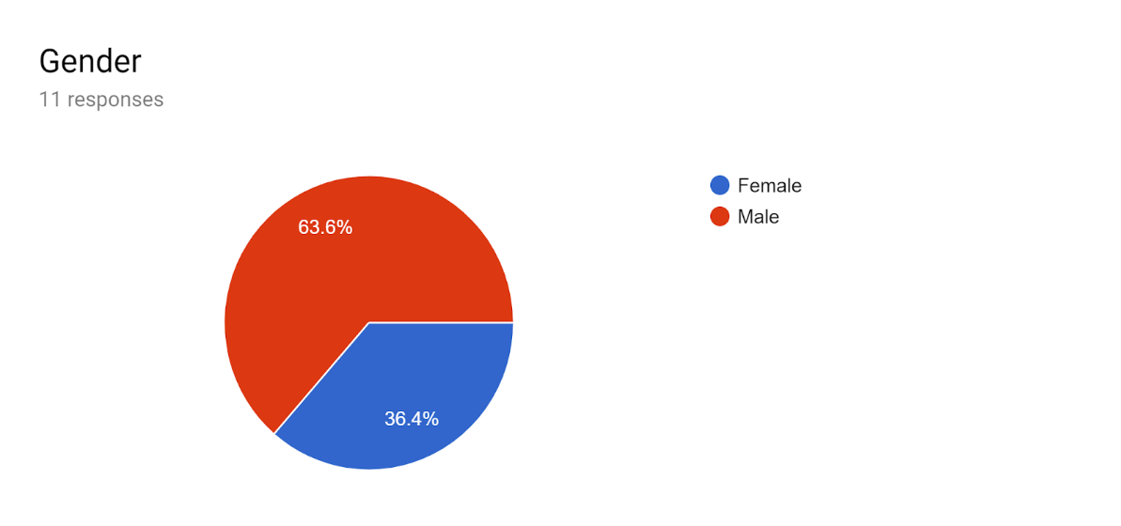

**2.  Table2: No of respondents disaggregated by designation:**

|  |  |
| --- | --- |
| Designation | No of respondents |
| TPI researchers | 5 |
| TPI interns | 4 |
| Guchusum researchers | 1 |
| others | 1 |

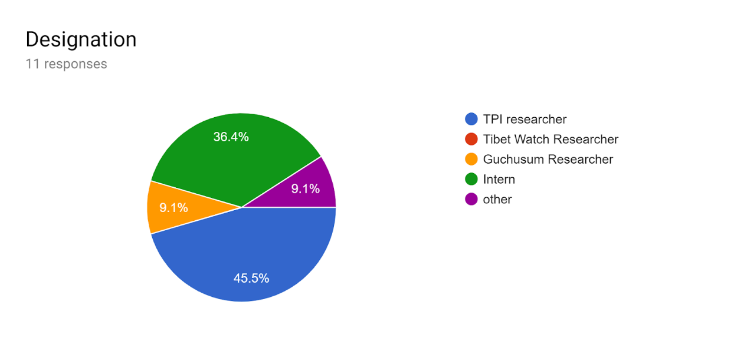

**3. Number of days attended for workshop by each surveyed trainee**

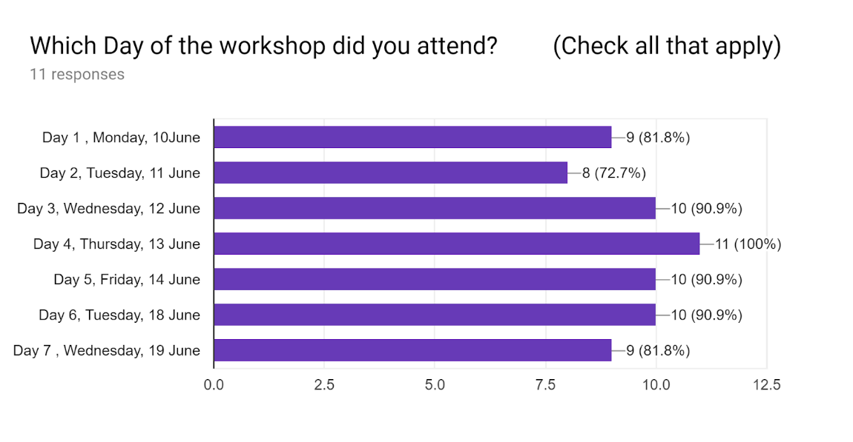

**Table3: Number of days attended for workshop by each surveyed trainee**

|  |  |  |  |  |  |  |  |  |
| --- | --- | --- | --- | --- | --- | --- | --- | --- |
|  | Day 1 | Day 2 | Day 3 | Day 4 | Day 5 | Day 6 | Day 7 | Days attended  per respondent |
| Respondent 1 | 1 | 1 | 1 | 1 | 1 | 1 | 1 | **7** |
| Respondent 2 |  | 1 | 1 | 1 | 1 |  |  | **4** |
| Respondent 3 | 1 |  | 1 | 1 | 1 | 1 | 1 | **6** |
| Respondent 4 | 1 | 1 | 1 | 1 | 1 | 1 | 1 | **7** |
| Respondent 5 | 1 |  | 1 | 1 | 1 | 1 | 1 | **6** |
| Respondent 6 | 1 | 1 | 1 | 1 | 1 | 1 | 1 | **7** |
| Respondent 7 | 1 | 1 |  | 1 | 1 | 1 | 1 | **6** |
| Respondent 8 | 1 | 1 | 1 | 1 | 1 | 1 | 1 | **7** |
| Respondent 9 | 1 |  |  | 1 |  | 1 | 1 | **4** |
| Respondent 10 | 1 | 1 | 1 | 1 | 1 | 1 |  | **6** |
| Respondent 11 | 1 | 1 | 1 | 1 | 1 | 1 | 1 | **7** |
| attendees per day | **10** | **8** | **9** | **11** | **10** | **10** | **9** | **67** |
| **mean attendance per respondent** | 6.09 |  |  |  |  |  |  |  |
| **mean attendance per day** | 9.57 |  |  |  |  |  |  |  |

Out of the 7 days of the training, there was 100% attendance by the surveyed trainees only on the fourth day of training. The remaining other days had varying attendance percentage by the 11 surveyed trainees. The mean attendance per day was 9.57 out of 11 respondents while mean attendance per respondent was 6.07 out of 7 days.

**4. Prior information about the objectives of the workshop**

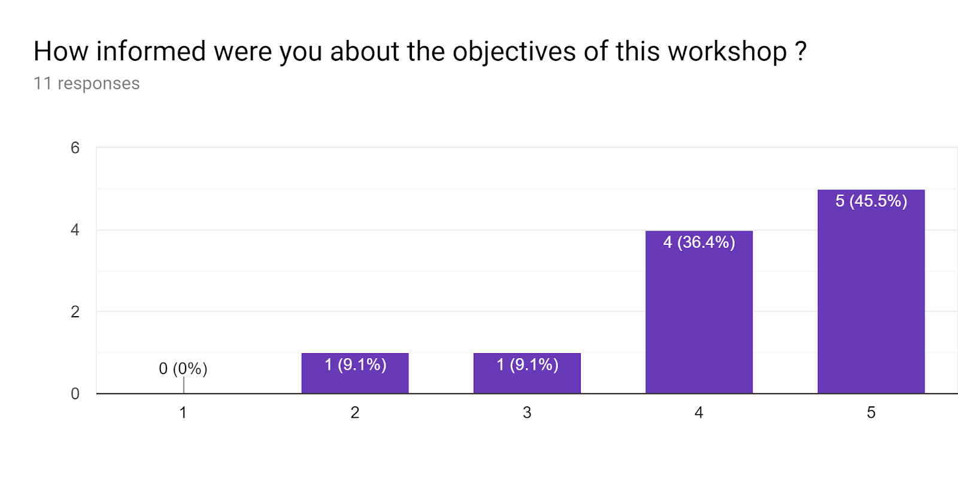

Out of the 11 respondents, 5 respondents responded to having been highly informed of the objectives of the workshop accounting to 45.5% of the respondents while 4 respondents accounting to 36.4% of the respondents responded to having been moderately informed of the objectives while 1 respondent accounting to 9.1% of the respondents agreed to have just been informed of the objectives. Only 1 responded to having not been adequately informed of the objectives of the workshop.

**5.  Perceived improvement in the surveyed trainees post the training**

**5a. Perceived improvement on the research methodology**

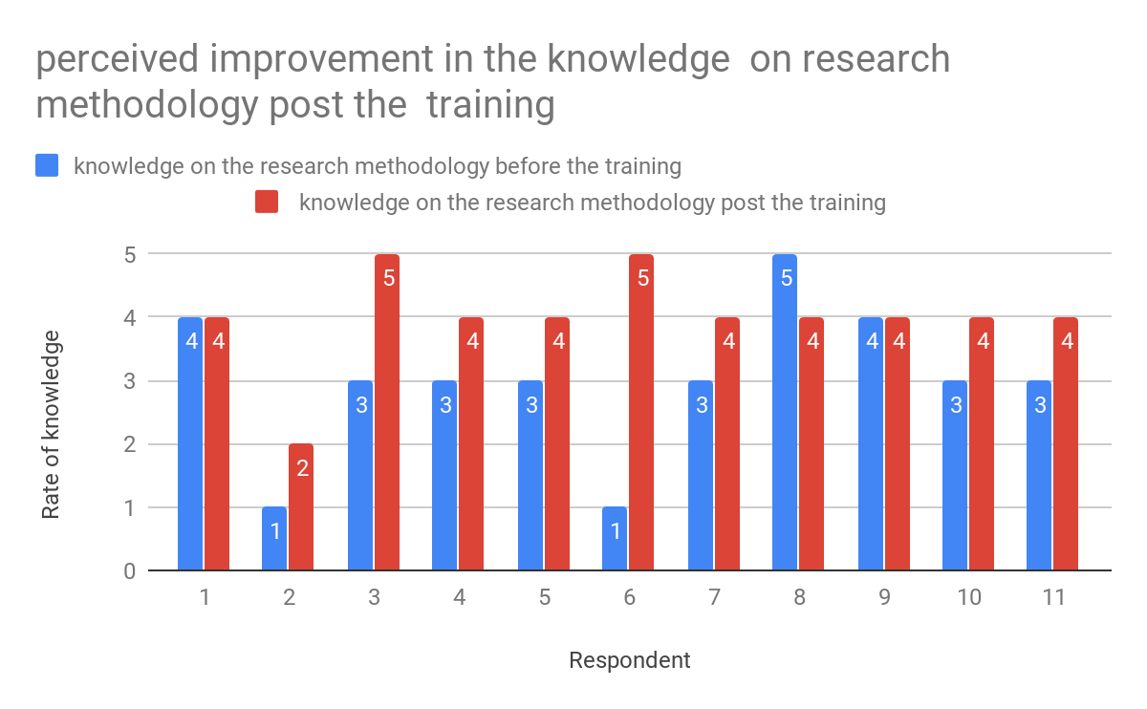

Out of the 11 respondents, 8 respondents perceived that their knowledge on the research methodology has improved post training while 2 perceived no improvement .One seem to have not properly understood or read  the questions.

Over all the mean knowledge of 3 before the training has been improved to a mean value of 4 after the training.

**5b. Perceived level of confidence in writing content on Asian philosophy**

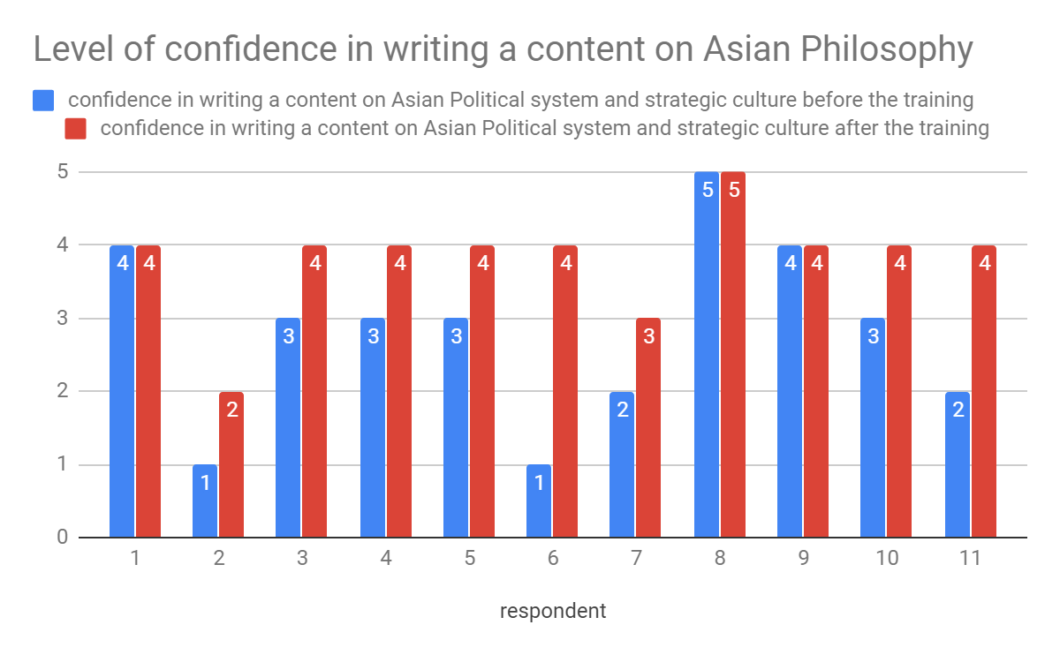

Out of the 11 respondents, 8 respondents responded to increased level of confidence in writing a content on Asian philosophy while 3 responded no improvement.

Overall the mean confidence increased from 2.82 to 3.82.

**6. Usefulness of the training to the surveyed trainees**

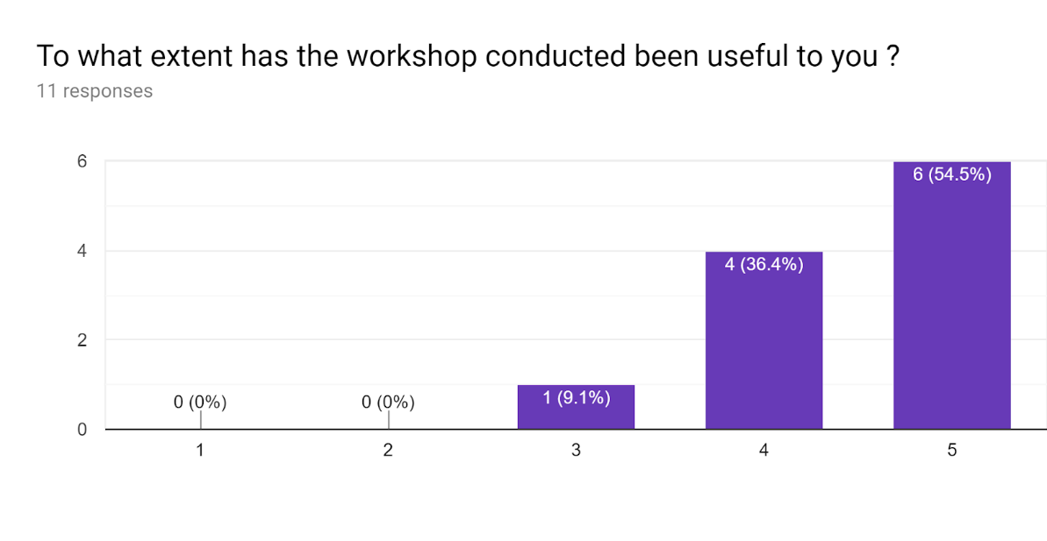

54.5% of the respondents responded that the workshop has been extremely useful to them while 36.4% of the respondents responded to workshop being useful to them. Only 1 respondent responded neutrally to the usefulness of the workshop.

**7. Relevance of the training in their daily job responsibilities**

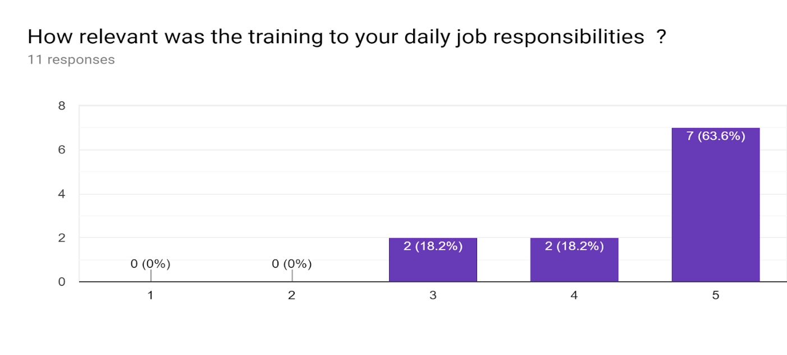

63.6% of the respondents responded to the training as being extremely relevant to their job nature while each of 18.2% responded to the training as being relevant and neutral.

**8. Perceived knowledge of the trainer:**

**8a. Content area**

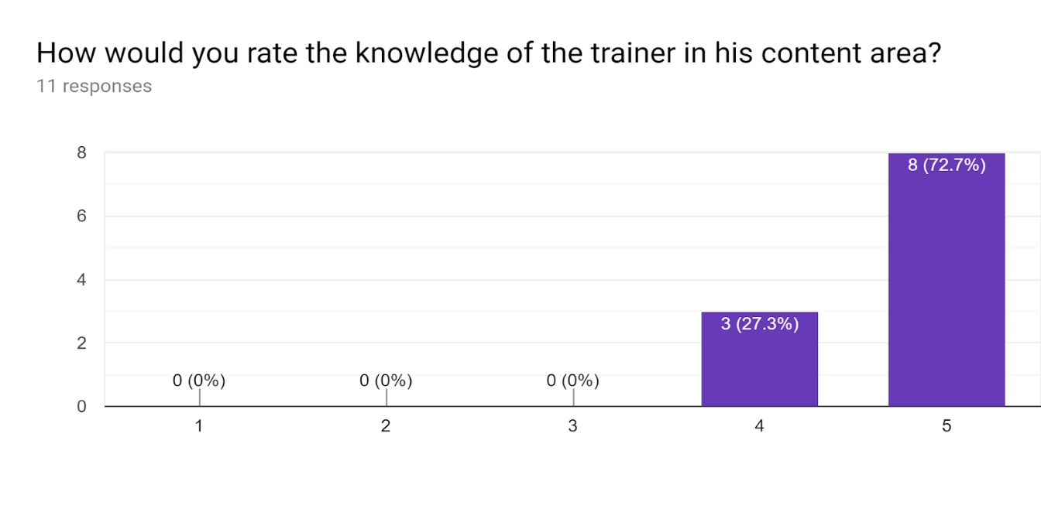

72.7% of the respondents rated the knowledge of the trainer in his content area as 5 indicating extremely high while 27.3% of the responded as 4 indicating high.

The mean perceived knowledge of the trainer in content area was 4.73.

**8b. Content delivery**

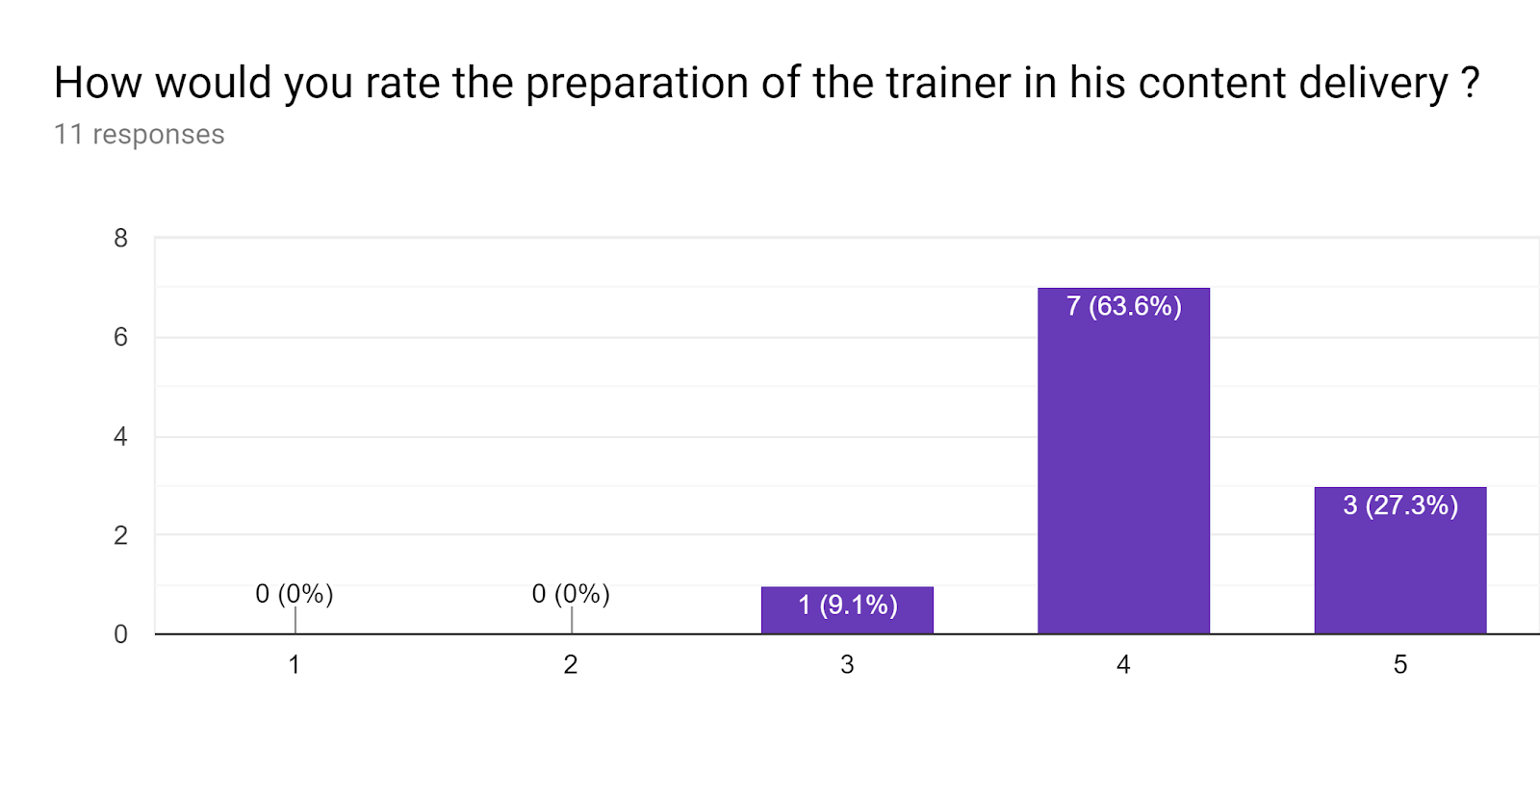

27.3% of the respondents responded to the preparation of the trainer in content delivery as extremely high while 63.6% of the respondents responded to the same as high. 9.1% of the respondents responded neutral.

**9.  Issues on Human rights and environment:**

**9a. Human rights:**

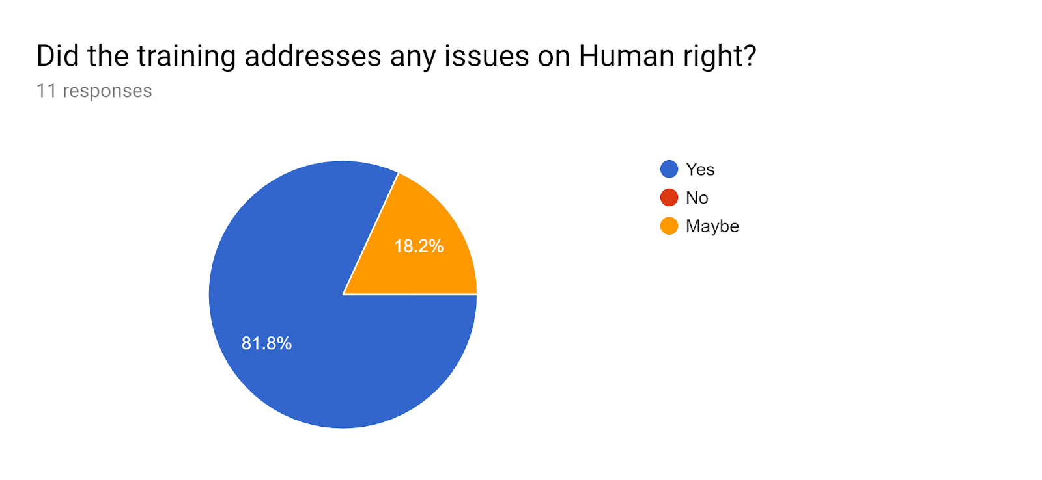

**9b. Environment:**

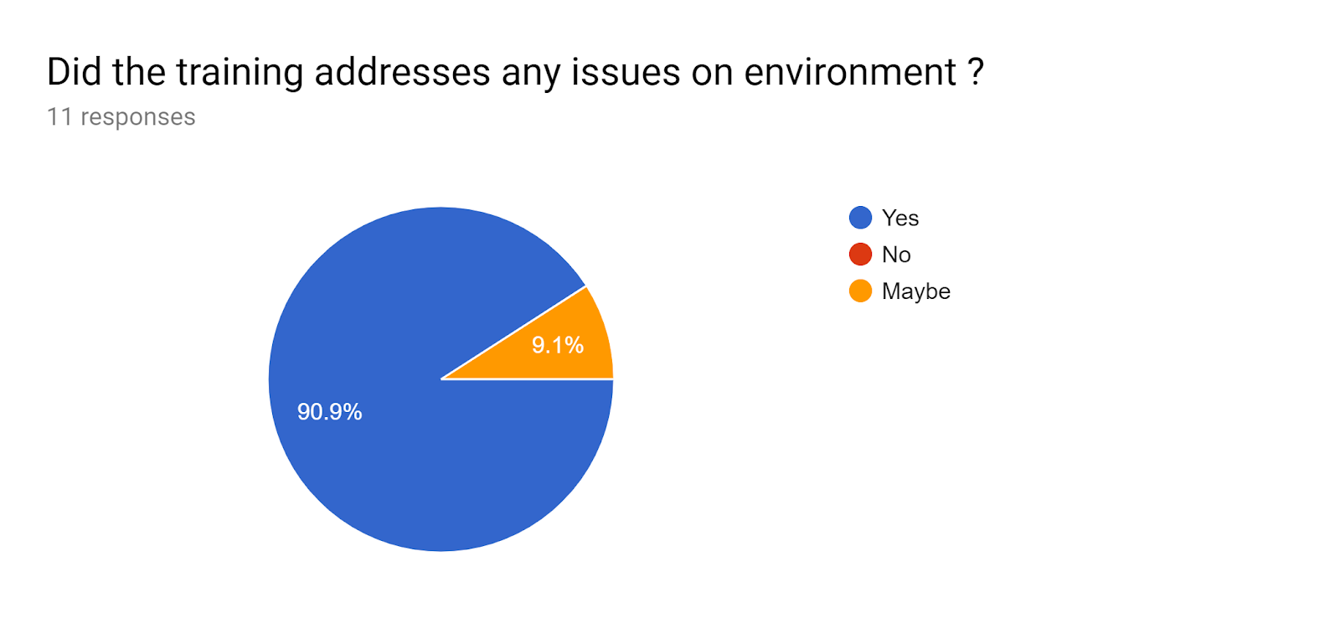

81.8% of the respondents agreed to having addressed the issue on Human rights while 90.9% of the respondents for the environment.

**10**.  **Knowledge on each of the topics discussed during the workshop:**

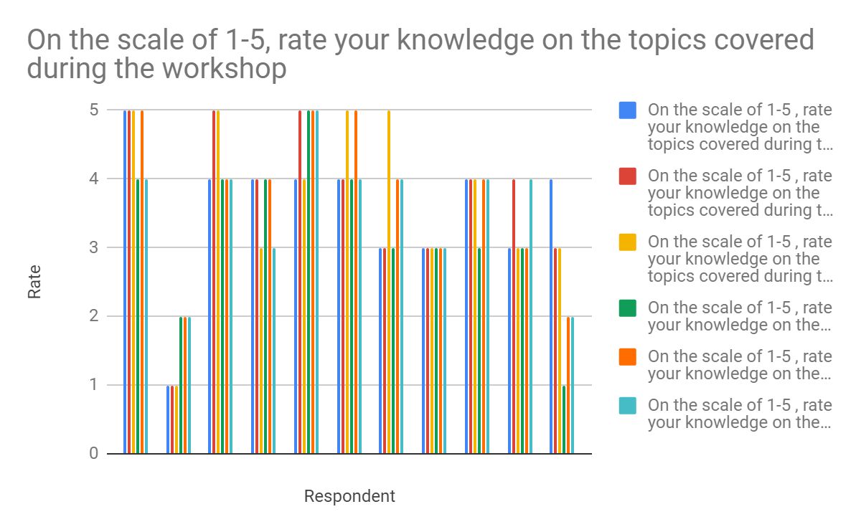

**Table4: Knowledge on each topic covered during the workshop**

|  |  |  |  |  |  |  |
| --- | --- | --- | --- | --- | --- | --- |
| **Respondent** | **[Knowledge system, Education and Research: Relations]** | **[Research methods, Technique and tools in the social science research]** | **[critical research writing and research awareness]** | **[Introduction of the Asian political thought and system ]** | **[Strategic culture of China, Tibet and India ]** | **[Diplomatic analysis and geopolitical relations between India , Tibet and China ]** |
| 1 | 5 | 5 | 5 | 4 | 5 | 4 |
| 2 | 1 | 1 | 1 | 2 | 2 | 2 |
| 3 | 4 | 5 | 5 | 4 | 4 | 4 |
| 4 | 4 | 4 | 3 | 4 | 4 | 3 |
| 5 | 4 | 5 | 4 | 5 | 5 | 5 |
| 6 | 4 | 4 | 5 | 4 | 5 | 4 |
| 7 | 3 | 3 | 5 | 3 | 4 | 4 |
| 8 | 3 | 3 | 3 | 3 | 3 | 3 |
| 9 | 4 | 4 | 4 | 3 | 4 | 4 |
| 10 | 3 | 4 | 3 | 3 | 3 | 4 |
| 11 | 4 | 3 | 3 | 1 | 2 | 2 |
| **Mean** | 3.55 | 3.73 | 3.73 | 3.27 | 3.73 | 3.55 |

Themean of the knowledge of the surveyed trainees was found to be lowest on the fourth day while the attendance on the same day was found to be 100% (Refer Table3). So it can be inferred that the trainee’s interest and attendance on the particular day accounts to low knowledge of the topics covered during the workshop. Thus the topic “Asian political thought and system” is recommended for the future training of the researchers.

**11. Suggestions:**

**11a. Based on survey questionnaire:**

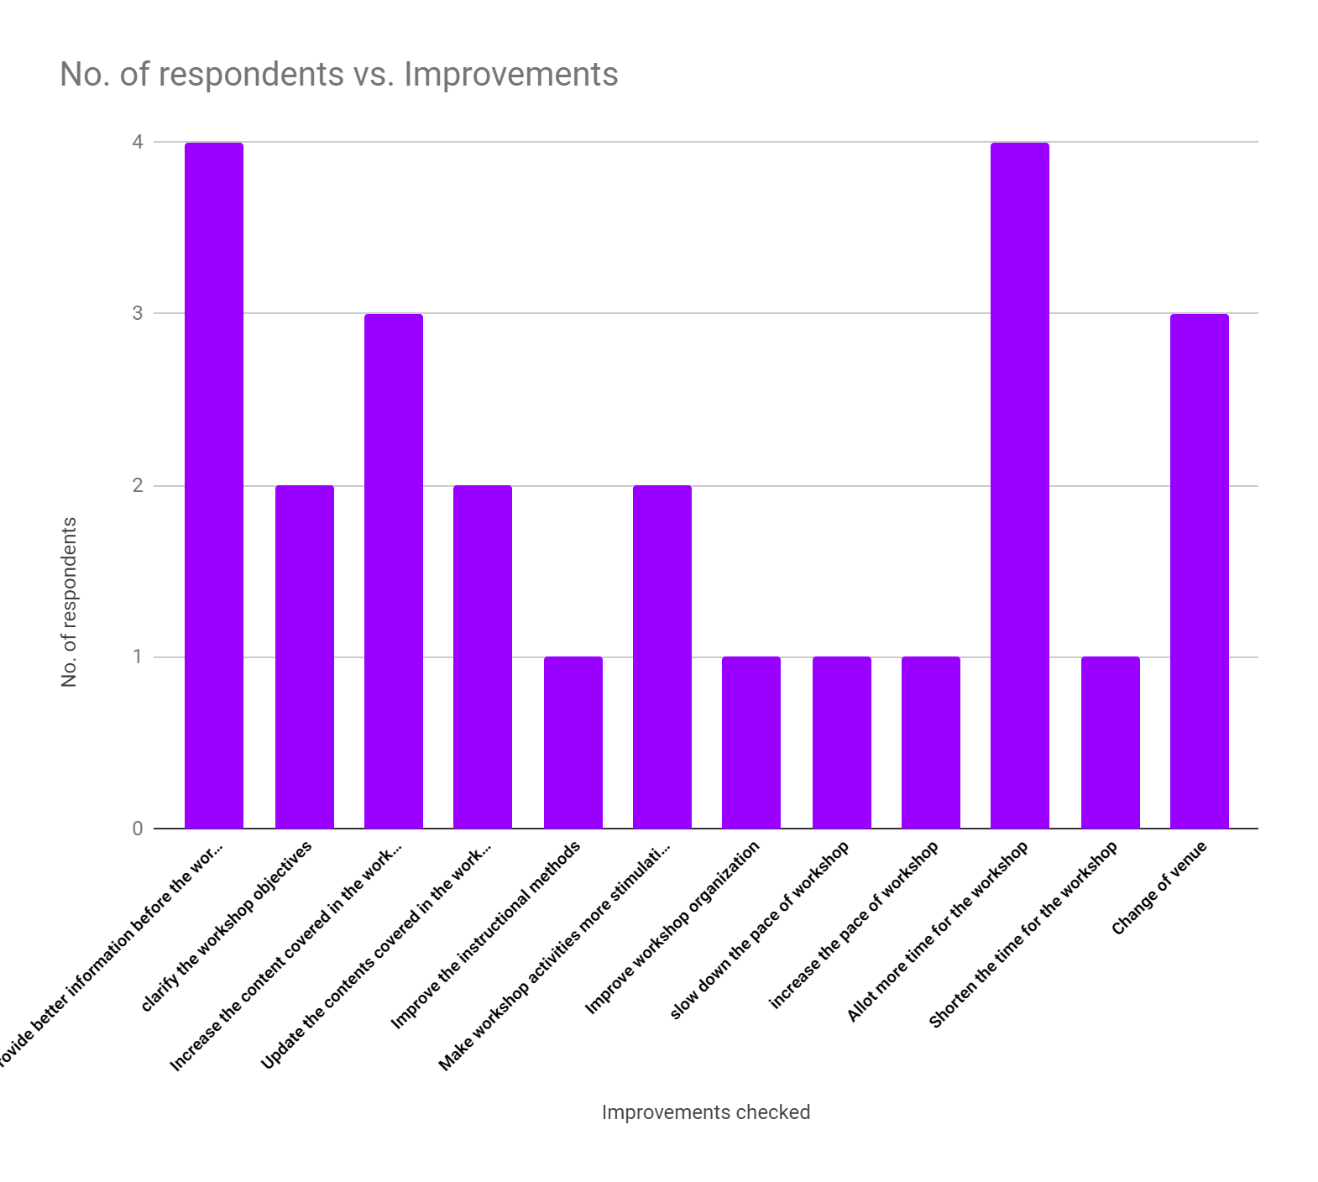

Out of the 11 respondents, 4 responded positively to providing better information before the workshop and suggested allotment of more time for the workshop while 3 responded to increasing the content covered in the workshop and Change of venue.

**11b. By Surveyed trainees on the relevant topics:**

* A lengthy and detailed workshop on research methodology and Asian strategic culture or Chinese political history, if provided to relevant staff working at different NGOs and CTA, would immensely help build the individual and the society in entirety.
* On Education and language of Tibetans in and outside
* Quantitative data collection and analysis
* Traditional Tibetan strategic culture
* Strategic culture of China
* More in depth about the impact of United States has on China's policies and how that affects Tibet and India.

**12. General observations:**

The EC supported training of the researchers had been informative and had improved the knowledge and skills of the trainees. The training in general has generated an interest in research work among them especially with the interns. With the training provided, their knowledge in research methodology had improved and gained confidence in writing content on Asian philosophy.

**13. Key recommendations:**

* Irregularities of the participant attendance  in the training was observed and was also depicted through survey responses , it would be good to have a set of instructions made clear to the participants before the training or change of venue to have 100% attendance rate so as to derive  a maximum learning experience .
* Training should be visually appealing as well. Use of ppt and multimedia is suggested.
* Training should include more activities to make it more stimulating.
* Given the importance of such training, a fixed duration of whole days should be set for the training rather than allocating short time intervals per day. This will alert the trainees of the importance of such training and will draw their full focus and attention to the same.

ANNEX 4: SURVEY REPORT

|  |  |
| --- | --- |
| **ACTIVITY** | 3.3.2  Researcher’s training 2 |
| **TOPIC** | Workshop on The Art and Craft of Opinion writing |
| **SURVEY DATE** | 18th Oct 2019 |

|  |  |
| --- | --- |
| **Written by** | Tenzin Yullo |
| **Reporting date** | 22nd Oct 2019 |

**Survey objective:** To measure the effectiveness of the training for trainees and to report on level of satisfaction in the subject and training.

Methodology:

**·** A survey method (Questionnaire) was used to assess the trainee’s perception of improvement in their professional skills and capabilities due to training received and also their perception of the effectiveness of the overall training. The questionnaire and sampling method were developed by SARD M&E officer and was reviewed by SARD.

·    Since the primary trainees are from TPI including researchers, visiting fellow and interns, questionnaire prepared was handed over to the participants through receptionist on 18th Oct 2019. The questionnaire was supposed to take a maximum of 10 minutes and thus the response was expected soon after in the afternoon itself. A total of 12 respondents were obtained. Two in completed forms were spotted which was then completed after a check with participants on 21st Oct 2019.

·     The data were collected anonymously to maintain transparency of view and opinion.

 .  The data obtained are then fed in excel.The survey data is further analyzed by SARD M&E and the result is reported.

Sampling:

     Out of the total strength of 14,  12 took part in the survey. Thus the response rate for this survey is 85.7%

Limitations:

* The participants/trainee list was requested during and after the training through mail on 4th Oct 2019 to which there were no response thus affecting the survey report in terms of time.
* However the signed list of the participants received later were not disaggregated by gender.
* One of the forms was incomplete which was completed later on.
* Since the list of participants is not received beforehand, the reasons for two missing respondents were not able to be traced.

Key Findings:

1. **Table1: No of trainees vs No of respondents disaggregated by gender**

|  |  |  |
| --- | --- | --- |
| Gender | Male | Female |
| No of trainees | 9 | 5 |
| No of respondents | 8 | 4 |

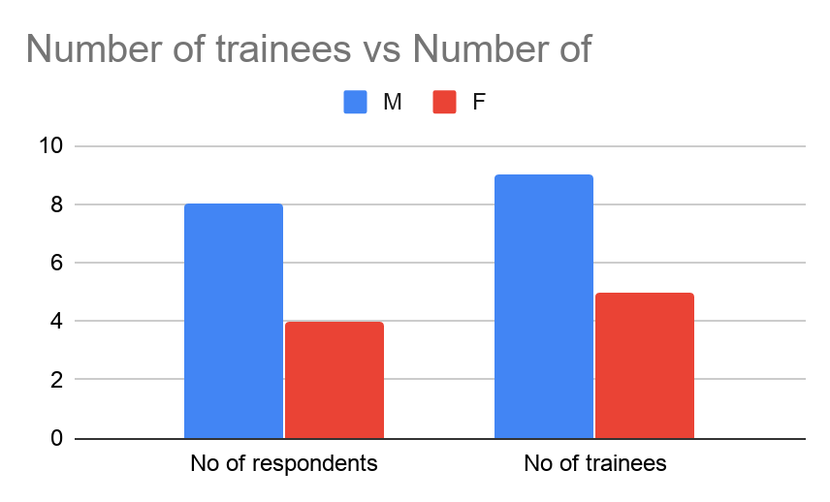

1. **Table2: No of respondents who have attended the same training in the past**

|  |  |  |
| --- | --- | --- |
|  | Yes | No |
| No of respondents having attended the same training in the past | 4 | 8 |

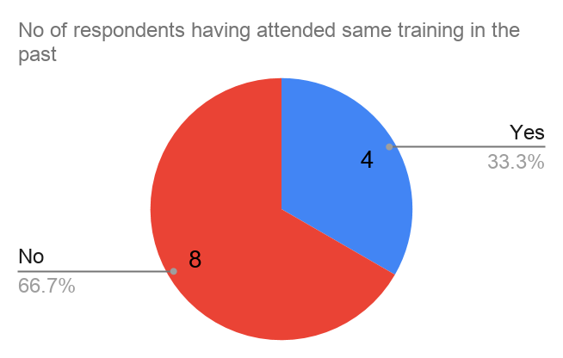

1. **Table 3 & 4: Measure of success of the training as perceived by the respondents**

|  |  |  |  |  |
| --- | --- | --- | --- | --- |
| measure | effectiveness | relevance | applicability | practicality |
| Mean | 5.33 | 5.83 | 5.58 | 5.08 |
| level | High | High | High | High |

The mean measure of success in terms of effectiveness, relevance, applicability and practicality lies within the range 5-6 out of maximum 7 points scale . Thus the level of the success of the training was perceived high

|  |  |  |  |  |
| --- | --- | --- | --- | --- |
| measure | effectiveness | relevance | applicability | practicality |
| percentage | 76.19 | 83.33 | 79.76 | 72.62 |

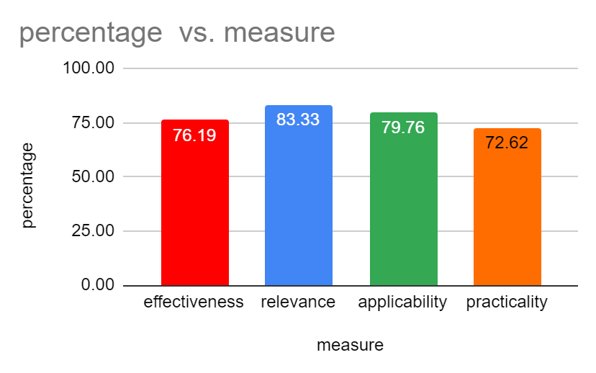

In terms of percentage, relevance of the training to the work was highest with 83.33% while practicality of the content scored lowest with 72.62%

**4.  Table 5: Perceived level of satisfaction**

|  |  |  |  |
| --- | --- | --- | --- |
| level of satisfaction | Extremely satisfied | satisfied | moderate |
| No of respondents | 5 | 5 | 2 |
| Percentage of respondents | 41.67 | 41.67 | 16.67 |

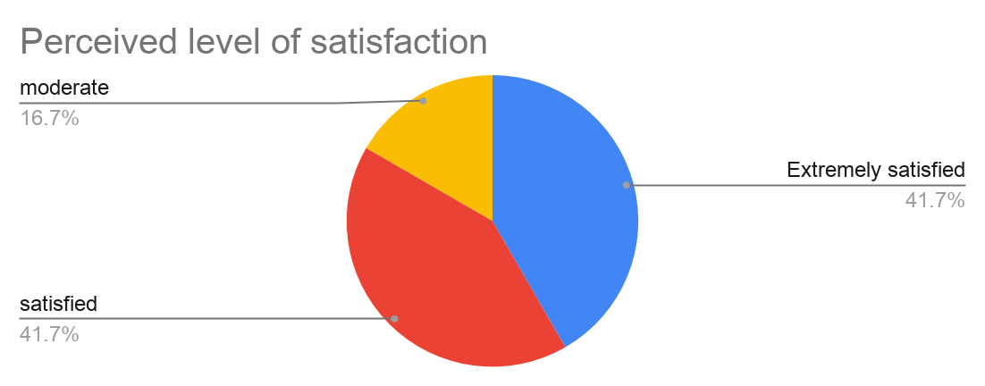

The percentage of respondents who are extremely satisfied and satisfied with the training are both 41.7% while the remaining 16.7% of the respondents were neutral in their response.

**5. Recommendations by the respondents**

5a. Content and skill improvement recommended for future training

* Ethics of good writing
* Training on power point presentation to better present the paper
* More research methodologies, techniques and writing training
* Training on academic paper writing
* Sample writing practice for writing articles
* Training on SPSS

5b. General recommendations for future training

* Change of training venue
* Longer duration of the training
* Training should not be conducted for the whole day . It either should  be arranged in the morning or afternoon session so as to balance off with other office works
* Allocating more time/days for practical exercise on opinion writing based on the theoretical classes will be more helpful
* More focus on individual topic of research with respect to opinion writing
* Need of the presentation prior to writing an opinion piece
* Little more preparation by the trainer
* More training on writing by professional writer

**6. General observations:**

The EC supported training of the researchers had been highly  effective, relevant, applicable and practical. The majority of the participants responded to having been satisfied with the training. They also expressed their appreciation of the trainer in terms of his knowledge and experiences in the topics covered. However, most of the trainees felt that the duration of the training was short and needs to be longer in the future.

**7. Key recommendations**

* The change of venue for such training in the future would be more helpful so that the researchers can fully commit their time to the said duration for the concerned topics rather than thinking of tending to other office work.
* More time duration of the training is recommended to derive the maximum benefit from the trainer in terms of availing one to one session and being able to do individual presentation as well.

**2.8.** What was your organisation or any actor involved in the action learned from the action and how has this learning been utilised and disseminated?

**2.9.** Please list all materials (and number of copies) produced during the action on whatever format (please enclose a copy of each item, except if you have already done so in the past).

*Please state how the items produced are being distributed and to whom.*

**2.10.** Please list all contracts (works, supplies, services) above EUR 60000 awarded for the implementation of the action for the whole implementation period since last interim report if any or during the reporting period, giving for each contract the amount, the name of the contractor and a brief description on how the contractor was selected, including compliance with EU restrictive measures.

**3. Beneficiaries/affiliated entities, trainees, and relations with Government/ other cooperation**:

**3.1**. How do you access the relationship between the beneficiaries/ affiliated entities of this grant contract (i.e. those having signed the mandate for the coordinator or an affiliated entity statement)? Please provide specific information for each beneficiary/ affiliated entity.

**3.2.** Is the above agreement between the signatories to the grant contract to continue? If so, how? If not, why?

**3.3**. How would you assess the relationship between your organisation and state authorities in the action countries? How has this relationship affected the action?

**3.4.** Where applicable, describe your relationship with any other organisation involved in implementing the action:

* Associate (s) (if any)
* Contractor (s) (if any)
* Final beneficiaries and target groups
* Other third parties involved (including other donors, other government agencies or local government units, NGOs, etc.)

**3.5.** Where applicable, outline any links and synergies you have developed with other actions.

**3.6.** If your organisation has received previous EU grants in view of strengthening the same target group, in how far has this action been able to build upon/complement the previous one (s)? (List all previous relevant EU grants).

**3.7**. How do you evaluate cooperation with the services of the contracting authority?

**3.8.** Where applicable, include a traineeship report on each traineeship which ended in the reporting to be prepared by the trainee including the result of the traineeship and assessment of the qualifications obtained by the trainee with a view to his/her future employment.

**4. Visibility:**

How is the visibility of the EU contribution being ensured in the action?

**5. Location of the records, accounting and supporting documents:**

Please indicate in a table the location of records, accounting and supporting documents for each beneficiary and affiliated entity entitled to incur cost.

Name of the contact person for the action: Nyima Yangzom

Signature: Location: CTA, Dharamsala

Report due date: 18/01/2020 Report sent: 13/01/2020